**2011 ISA Annual Prairie Chapter Conference**

**& Tree Climbing Championship**

**September 10 - 14, 2011**

**Winnipeg, Manitoba**

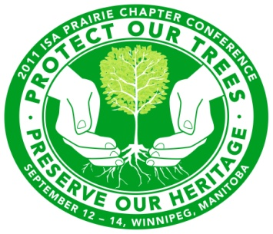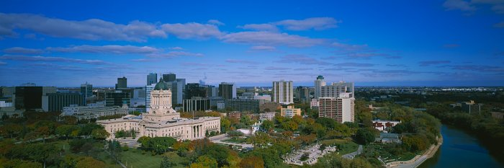

The 2011 ISA Prairie Chapter Annual Conference and Tree Climbing Championship will be held in Winnipeg, Manitoba from September 10 to14, 2011. An overview of the Conference and TCC schedule includes the following activities:

* **Saturday, 10 September:**  Tree Climbing Championship (TCC) Masters’ Qualifying Events
* **Sunday, 11 September:** TCC Finals
* **Monday, 12 September:** Pre-Conference Sessions, Trade Show, and Wine and Cheese Reception
* **Tuesday, 13 September:** Educational Sessions and Trade Show & Gala Dinner & Dance
* **Wednesday, 14 September:** Educational Sessions

**Keynote Speaker: Dr. Kevin Smith USDA**

Kevin began his research work in forest pathology in the USDA Forest Service lab of Dr. Alex Shigo in 1977. Since 2000, Kevin has lead a research team for the Forest Service that investigates the role of stress and disease on forest health and productivity. His personal research topics include the response of trees to injury, infection, and environmental disturbance. He also examines the role of wood decay in soil formation and forest fertility. He is frequently invited to present these themes to arboricultural and land management groups and has authored more than 90 publications in scientific journals, books, and green industry magazines.



**A detailed schedule of events and registration is available to download at** [www.isaprairie.com](http://www.isaprairie.com)