Our Vision
Pat Lintaman Design Ltd. is developing an eco-industrial park on five hectares of land in the Shawnigan Lake area of the Cowichan Valley Regional District on Vancouver Island. We're developing the Shawnigan Eco-Industrial Park for three reasons:
- To show that business and industries can be both ecologically and economically sustainable, and that it's possible to make a living while supporting or even restoring the environment;
- To show that interconnected businesses can generate the greatest possible value from local forest resources, while reducing costs, waste, and carbon footprints; and
- To show how an Eco-Industrial park can be the cornerstone of sustainable, resilient communities (especially forest communities).
The Shawnigan Eco-Industrial Park plans to demonstrate that when businesses with complementary waste products and resource needs are co-located, the net result supports rather than burdens the surrounding community, and can solve existing problems such as waste disposal and a degraded watershed. The Shawnigan Eco-Industrial Park is designed using the principles of industrial ecology, where each unit of water, energy, and material can be used for its highest and best use and value. The result for enterprises in the park will not only be lower operating costs, but also lower carbon emissions and a lower ecological footprint.
The Shawnigan Eco-Industrial Park be likely be based on a co-operative model, in which each enterprise owns shares in the park's infrastructure.
We're also keen to show that these principles can work on a relatively small scale of five hectares. The model will be reproducible, and the lessons we learn will be shared with like-minded developers and communities around the world. The Shawnigan Eco-Industrial Park will also offer education to the public, who will be welcomed to understand how it works by visiting the park in person, and by visiting the website which will explain how the industrial ecology systems work, and provide real-time performance information.
(visit www.shawniganecoindustrialpark.com)

The Eco-Industrial Model
North American cities and industries tend to be based on a "straight pipe" model, in which resources are extracted, used, and discarded. This is very different from nature's "closed loop" model however, in which waste from one organism becomes food for another, and in which water and materials are continuously recycled. While cities based on "straight pipes" are vulnerable to interruptions in the supply of water, energy, and materials, an eco-industrial park is more self-sufficient and so is more resilient.
An eco-industrial park is designed to mimic nature's cycles: enterprises with complementary waste products and resource needs are co-located, and resource recovery infrastructure is provided to convert waste into inputs. The Hammaryby Sjöstad sustainable development in Stockholm is based on this eco-industrial model, in which nothing is wasted. The graphic below shows how water, energy, and materials in the development are arranged in Hammarby Sjöstad:
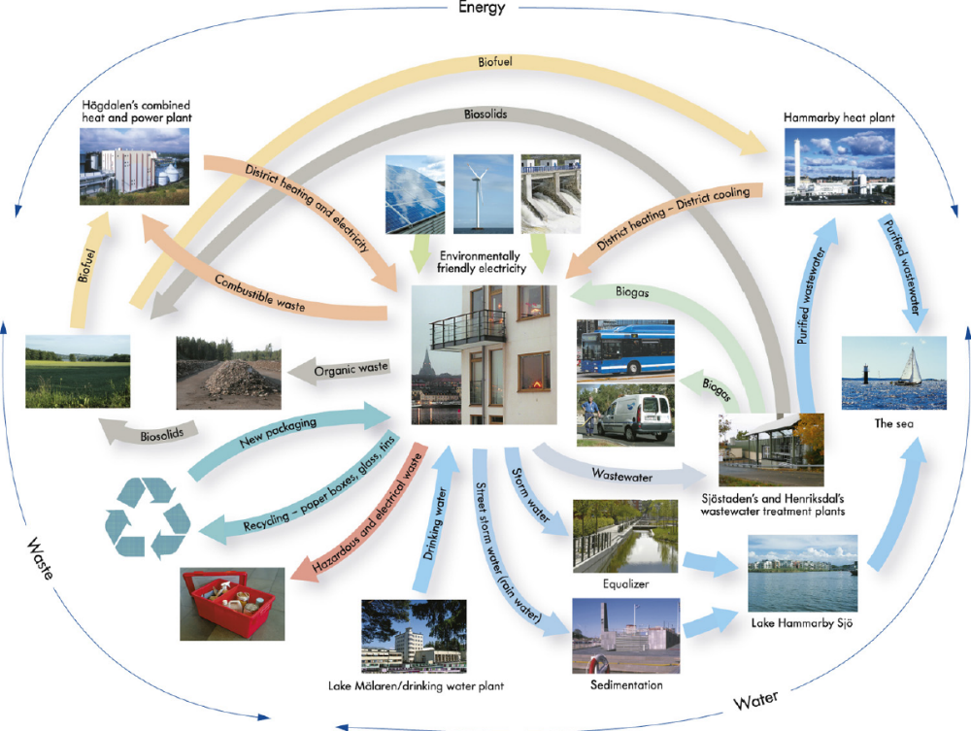

The Shawnigan Eco-Industrial Park
Businesses will be invited to join the Shawnigan Eco-Industrial Park based on their complementary needs. The graphic below illustrates this concept:

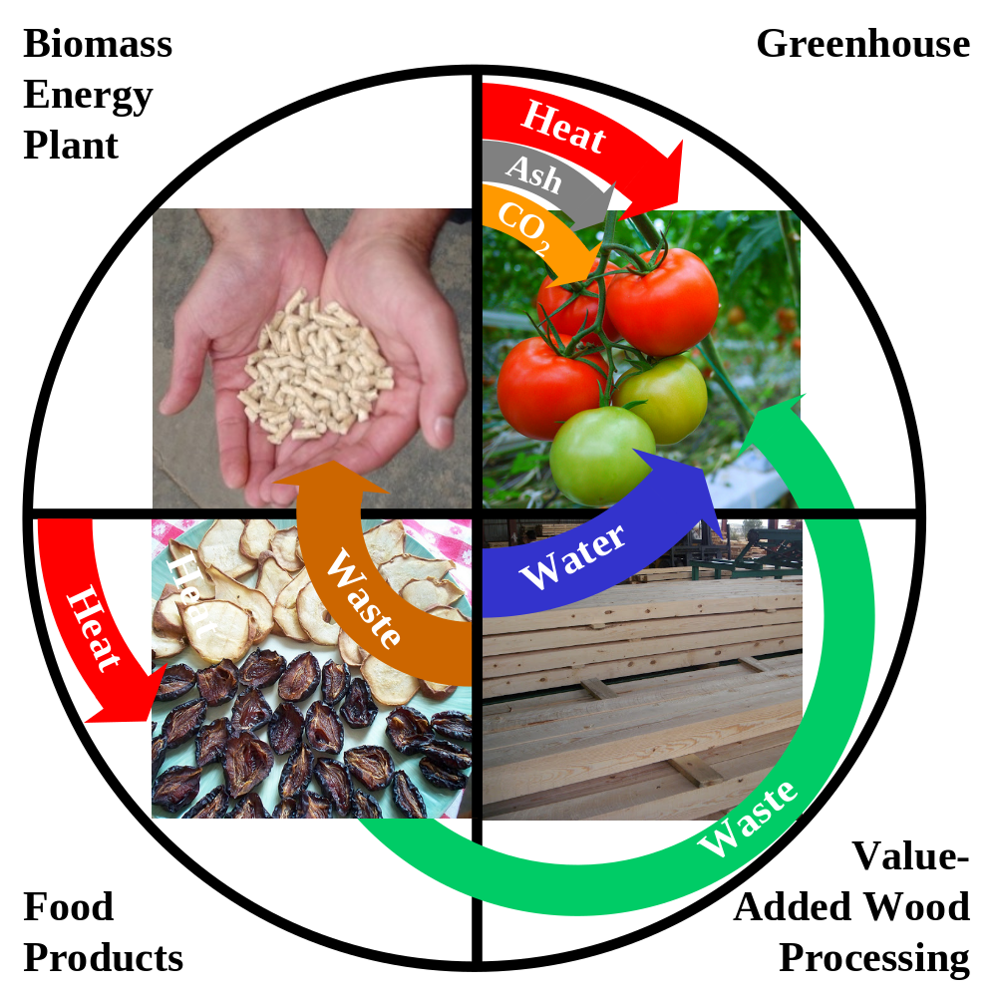

The graphic shows just one possible set of complementary enterprises for the Shawnigan Eco-Industrial Park. An anchor tenant such as a biomass plant (e.g. a briquette plant) could process wood waste from wood-based manufacturing with in the Shawnigan Eco-Industrial Park, supplemented by urban wood waste from the community, and industrial wood residues from local sawmills and local silvaculture. In addition to briquettes, the biomass plant would also produce waste heat, ash, water, and carbon dioxide which could be used to reduce the operating costs of an adjacent greenhouse. Waste heat could also replace fossil fuel or electricity in an adjacent food dehydrating business, for example. Organic waste from the greenhouse and food processing company could be supplemented by food waste from the community to produce biomethane through anaerobic digestion. Wastewater would be treated and reclaimed on site, and reused to the greatest extent possible.
The net ecological footprint of the Shawnigan Eco-Industrial Park will be much lower than comparable industrial parks, due to the careful use of industrial ecology to balance the inputs & outputs of member enterprises. In addition, buildings and facilities will be LEED certified. As the Shawnigan Eco-Industrial Park is developed, the opportunity to account for and sell carbon credits will also be evaluated.
The site of the Shawnigan Eco-Industrial Park has been zoned eco-industrial by the CVRD through Zoning Bylaw No. 985, I-5 Zone Eco-Industrial) - this is a unique designation. From here, the Shawnigan Eco-Industrial Park will be developed in phases:
- Site preparation, levelling and services
- Secure an anchor tenant whose business is based in biomass
- Find complementary and symbiotic businesses
- Balance the flows of energy, water, and materials
- Complete detailed design of buildings and eco-industrial infrastructure
- Construction
- Evaluate performance
- Share lessons-learned

Measuring the Results
We will use the Natural Step to develop performance targets and performance indicators for the Shawnigan Eco-Industrial Park, such as:
- Electricity generated on site, and economic turnover per unit of electricity $/kWh)
- Low-carbon heat generated on site, and economic turnover per unit of energy ($/kWh)
- Water recycled on site, and economic turnover per unit of water ($/m³)
- Carbon productivity (tonnes of CO₂ per $ of economic turnover)
- Economic turnover per unit of raw material such as wood ($/m³)
- Hours of employment per unit of raw material (hours/m³)
- Economic turnover from forest products per hectare of the development ($/hectare)

The Shawnigan Eco-Industrial Park and the Community
The Shawnigan Eco-Industrial Park will show that when businesses are connected through industrial ecology, the results support rather than burden the surrounding community and ecosystems. Instead of relying on the community to process industrial waste for example, the park will be able to process waste from the community. The Shawnigan Eco-Industrial Park will also show how each unit of water, energy, and material can be used for its highest and best use and value.
The Shawnigan Eco-Industrial Park will also provide local, sustainable jobs.

Sharing the Results
We will welcome public participation through tours of the park, and by providing virtual access through a website which will explain how the park's industrial ecology systems work. The website will also include real-time performance information showing flows of energy, water, and other materials among the park's businesses.

How Your Business Can Fit In
Industrial ecology in the Shawnigan Eco-Industrial Park will reduce the operating costs of businesses, especially those which require large amounts of energy. Businesses in the Park will be able to exchange their waste resources, which will provide additional income for the seller, and reduced costs for the buyer. For example, a biomass plant could sell its waste heat through a co-operative, while a buyer would purchase low-carbon heat at a lower cost than conventional fuels.
Your business could also benefit from the marketing advantage of green branding for your products. A logo will be available to show your customers that your product was made in an eco-industrial development, with low-carbon energy and low consumption of other resources.
We are inviting businesses to become tenants, and potentially even shareholders, in the Shawnigan Eco-Industrial Park and its co-operative. If this idea appeals to you, or if you would like further information, please feel free to reach us:
Pat Lintaman
Pat Lintaman Design Ltd.
Phone: (250) 478-0795
Email: pat@topnotchlog.com

