ISA ONTARIO CONFERENCE CALL FOR PAPERS
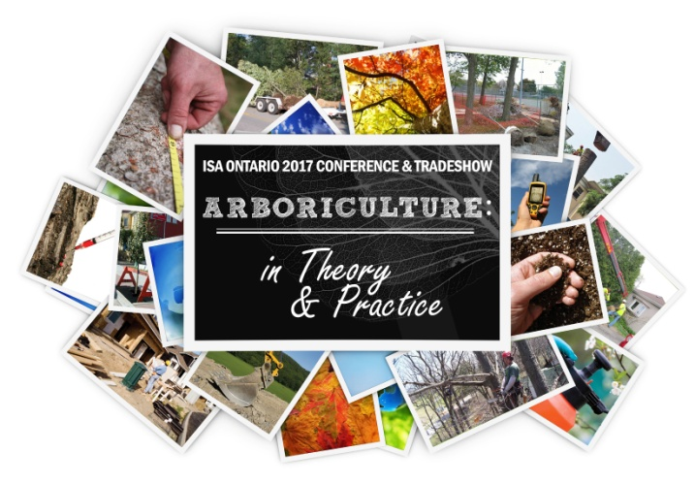
ISA Ontario’s 68th Annual Educational
Conference and Tradeshow

MARRIOTT GATEWAY ON THE FALLS
6755 Fallsview Boulevard
Niagara Falls, ON L2G 3W7
February 22 to 24, 2017

The ISA Ontario Chapter is now seeking presentation proposals
for its 68th Annual Educational Conference. This is the premier gathering
of arboricultural professionals. Foresters, urban foresters, practicing arborists, educators, students and more come together with top researchers and educators to learn the latest in research, technology and innovations in arboriculture.

2017 Conference Theme:
Submissions Due to ISAO office by
August 10, 2016

Arboriculture: In Theory & Practice

Throughout the arboriculture industry, arborists struggle to protect and care for trees in construction zones, urban environments and other situations with influences beyond their control. The importance of including trees at the planning stage and the effectiveness of tree protection by-laws impacts the ability of arborists to maintain a healthy urban canopy. In situations where the trees may not be the primary focus of the project, preservation options may become limited and remedial actions are the only option. As these challenges face us, there is potential to develop innovative tools to enhance and promote the care of trees for present and future generations

With this Conference, the ISA Ontario Education Committee aims to address the issues associated with trees in construction and environmental disruptions and to introduce innovative ideas and information.

Presentation proposals are now being accepted for topics on:
- Building Specifications and Municipal By-laws that impact the preservation or planting of trees during the planning and construction phases
- Tree preservation by-laws; writing in theory and enforcing in practice
- Arboriculture and the Law in Ontario, including case studies and court decisions
- Soil management; dealing with compaction, drainage, and nutrient availability
- Incorporating trees at the planning stage; accommodating new tree plantings and preserving existing trees
- New planting species available to us in our changing environment
- Cost and benefit analysis of trees, applied to preservation decisions
- Tree Worker Topics including Safe Working Practices, Climbing Techniques, Advanced Rigging Techniques
- Management topics including:
  - Attracting, hiring and retaining good employees
  - Customer relations
  - Maintaining a balance between productivity, safety, and a positive working environment
  - Determining your desired customer demographics and working to attract those customers
- Other, please describe the topic in your application

Types of Presentations include:
- Individual Presentations (30 minutes to 2 hours)
- Symposia or panels (1 hour to 2 hours)
- Specific presentations for municipal, commercial or utility arborists (1 hour to 2 hours)
- Workshops or hands on presentations (1 hour to 2 hours)
- Research Posters

Proposals will be evaluated based on overall appropriateness, focus, and practical application of material, and the subject’s interest to a diverse audience.
Speakers whose presentations are selected will be required to sign a confirmation agreement and submit additional details in advance of their presentations.

  - ISA Ontario Conference ‘Call for Papers’ Application Form

Name of Primary Author or Presenter:

Organization:

Address:

City, Province/State, Zip Code/Postal Code, Country:

Phone: Fax:

Email:

Biography (50 word maximum):

Profile Picture (send as an attachment):

Name of Secondary Author or Contact:

Organization:

Address:

City, Province/State, Zip Code/Postal Code, Country:

Phone: Fax:

Email:

Biography (50 word maximum):

Profile Picture (send as an attachment):

Title of Presentation:

Presentation Abstract (300 word maximum):
(Please type abstract here or send as an attachment)

Presentation Type (please check appropriate box):
- Individual Presentations (30 minutes to 2 hours)
- Symposia or panels (1 hour to 2 hours)
- Specific presentations for municipal, commercial or utility arborists (30 minutes to 2 hours)
- Workshops or hands on presentations (1 hour to 2 hours)
- Research Poster presentations

Preferred Length (please check appropriate box):
- 30 minutes
- 45 minutes
- 60 minutes
- 90 minutes
- 120 minutes

Presentation Requirements (please check appropriate boxes):
- LCD Projector
- Laptop
- Other, please list:

Budget:

Automobile Travel
If your presentation is accepted, will you travel by automobile? (delete one) YES or NO
If YES, what is your round trip mileage to and from Niagara Falls?

Travel by Flight
If your presentation is accepted, will you travel by plane? (delete one) YES or NO
If YES, what are your estimated flight/travel costs to Ontario: Pearson International Airport (YYZ) or other airport in Canadian funds? (Buffalo Niagara International (BUF); JCM Hamilton International Airport (YHM))

Speaker Fees
What is your approximate speaker fee for your presentation in Canadian funds?

Other:

(Please enter additional comments and/or requirements here):

Signature: __________________________________________

Date: ___________________________

Submissions are Due to ISAO Headquarters by Aug 10, 2016
Call for Paper Applications can be sent to:
ISA Ontario
If you wish to apply for more than 1 presentation, please complete the attached application form separately for each topic.

All presentations will be presumed to be given in English.

7856 Fifth Line South
Milton, Ontario L9T 2X8
Ph. 1-888-463-2316 or 416-493-7022
Fax: 1-855-329-4726
Email: info@isaontario.com

