School of Construction and The Environment
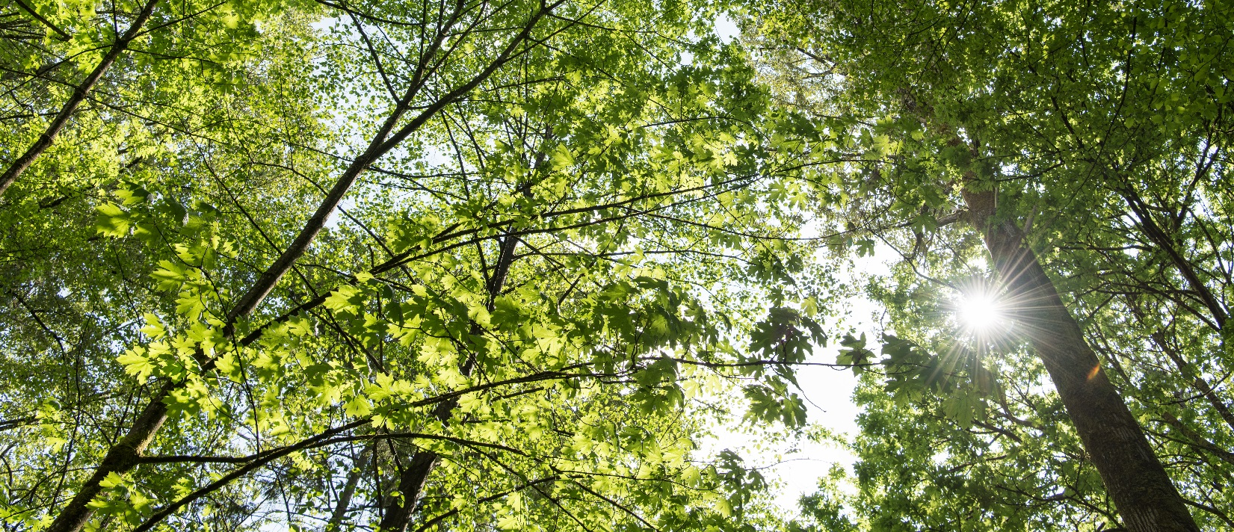Urban Forest Assessment
The Urban Forest Assessment course will provide training for the assessment of urban trees and forests and calculation of their contributions to CO₂ reduction, storm water management and other ecological services. The use and application of the i-Tree software platform is used and discussed as a method for observing, recording, analysing tree data and for the calculation of the ecological services of a tree or forest area. Students will be trained using a combination of online and face to face methods.
Urban forest Assessment
Starting May 6th, 2019 for online components. Field sessions on May 25th & 26th 8:30am-4:30pm
The Urban Forest Assessment course provides training in ecosystem values and assessment protocols for urban forests and the application of this information in regional land management. This knowledge is increasingly relevant in municipal planning and in the assessment and enhancement of natural capital and infrastructure. I-Tree software provides an economic value for ecological services such as for pollution mitigation, avoided runoff, carbon sequestration, and provides valuable information about pest and storm water risk management. This course includes an understanding of the basics of urban forest assessment, the ability to sample larger areas or patches of urban trees, compile, prepare and submit data to the i-Tree system. Students will also have the opportunity to review a typical i-Tree report.
The Urban Forest Assessment course is applicable for students studying ecological restoration, forestry, resource management, arborists, planners, consultants, stewardship groups and teachers. The course will consist of 8 hours of online learning and 16 hours of combined classroom and field work. Online components will self-directed and completed over a three week period. Field work studies will be completed face to face on campus over a weekend.
FOR MORE INFORMATION
Julia Alards-Tomalin | 604-456-8175 | jalardstomalin@bcit.ca | www.bcit.ca/renr1050

