

Registered Disability Savings Plans
and the Disability Tax Credit

Information Session

January 25th 1:00 to 3:00 pm

Canadian Mental Health Association Ottawa
1355 Bank Street, 4th Floor
Boardroom A

Please register by calling 613-737-7791
or email kmcmullin@cmhaottawa.ca

Guest Speaker Jane Enright from Compas Consulting
on behalf of the Government of Canada

The session will answer a number of questions:
What is the Disability Tax Credit (DTC) and how do you get it?
Why do you need a DTC for a Registered Disability Savings Plan?
What exactly is a Registered Disability Savings Plan
and do you (or does your family member) qualify?
Can a person with disabilities really get “free” money from the government for retirement? (Yes! possibly … come see if you/your family member might qualify)

Come and find out how you can benefit
from these government programs

Please register: 613-737-7791 or kmcmullin@cmhaottawa.ca

Sponsored by the Financial Accessibility Committee of
CMHA Ottawa Branch:
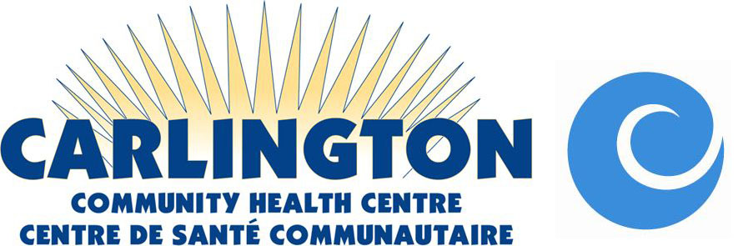

and Consumer & Family Volunteers

