Bed Bugs: A Practical Training Session for Service Providers
Please join us as Public Health Inspector’s discuss the following topics:

- Introduction to Bed Bugs
- Prevention and Control of Infestations
- Preparing for Home Visits
- Receiving Clients in an Office Setting

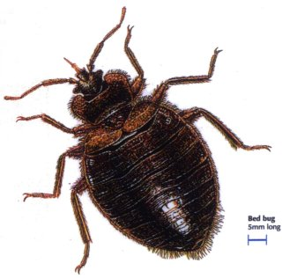

Thursday, February 23 OR Tuesday, February 28, 2012
9:00am-11:30 am (English)
Tuesday, February 28, 2012
1:00-3:30 (French)

Jim Durrell Recreation Centre
1264 Walkley Road
Ottawa, ON

This event is free. Registration is required. Coffee and snacks provided.
Please complete the attached registration form and return it by February 17, 2012

 This initiative has been generously funded by the Ontario Ministry of Health and Long-Term Car

Bed Bugs: A Practical Training Session for Service Providers

Thursday, February 23, 2012 or Tuesday, February 28, 2012
Jim Durrell Recreation Centre-1264 Walkley Road

Please complete the following form and return to bedbugs@ottawa.ca or fax to (613) 580-9648 no later than February 17, 2012.

Please check which date you will be attending
February 23, 2012 9:00-11:30 am (English)
February 28, 2012 9:00-11:30 am (English)
February 28, 2012 1:00-3:30 (French)

Name of Agency/Organization
Name of Participant
Mailing Address
Phone
Fax
Email

