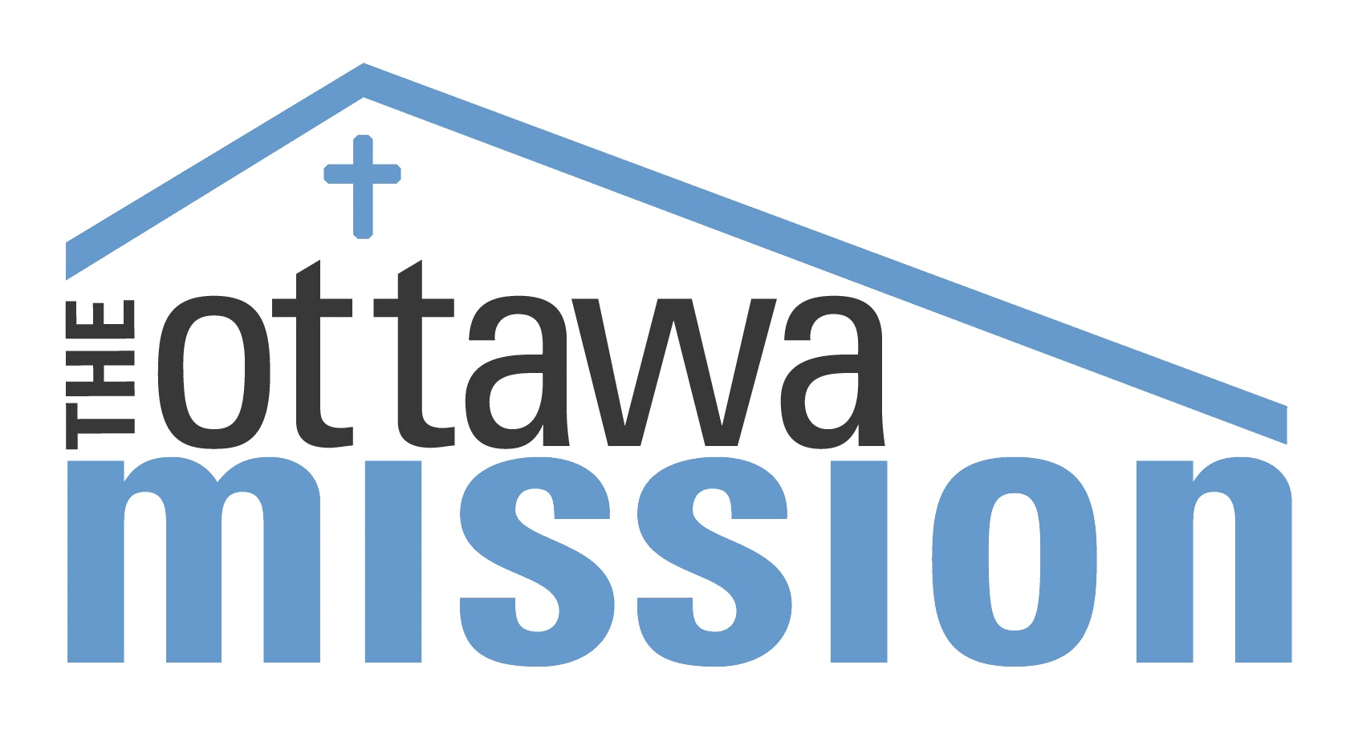
ADDICTION SERVICES
at The Ottawa Mission
CHECK US OUT!
35 Waller Street, Ottawa Ontario

Out-Patient Addiction Services (Day Program)
613-234-1144 ext 313
The Day Program involves educational groups and individual counselling for all men and women with addiction or concurrent issues in the shelter system or community. The program is primarily directed at engaging people who have never had or never considered addiction treatment, or who may have considered getting help for their addiction but struggled with motivation, remained ambivalent or was unaware of community resources. A secondary goal is to provide support to persons actively seeking recovery.

There is no intake or assessment process. You only need to show up at The Ottawa Mission’s chapel between 8:30am and 9:00am to participate in group (free coffee and snacks are provided). There is no need to make any commitment to this program. You may simply drop in whenever you would like. However, individuals who do make a commitment to attend the group regularly may get a certificate of completion after 1 month, 3 months and 6 months.

Counselling services are also available for participants. Sign up before or after group.
You must be clean and sober while participating in group or counselling.

Beds are available to participants of the Day Program in a reserved wing of the shelter called the Dry Wing. These are still shelter beds but the wing is moderately secluded from the rest of the shelter and each room is much smaller, holding just 2 beds per room. This space provides Day Program participants with a greater sense of security and community. Clients staying in the Dry Wing must attend at least one group each day and must not be under the influence while in the wing. Speak to a counsellor about booking in.

Other weekly educational courses are also available periodically including a Seeking Safety, Anger Management and Early Recovery Strategies. Please check with a counsellor for the next opportunity to sign up.

Day Program | Seeking Safety | Early Recovery Strategies
Counsellor: Tim Gauthier | Counsellor: Krista Holts | Counsellor: Nick Delroy
Group : 9:00am to 10:30am (Monday to Friday – Drop in) | - Closed group  - Weekly for 8 weeks  - Call to get the next start date and to register | - Closed group  - Weekly for 9 weeks  - Call to get the next start date and to register
Counselling appointments available

ADDICTION SERVICES
at The Ottawa Mission
CHECK US OUT!
35 Waller Street, Ottawa Ontario

Stabilization
613-234-1144 ext 299
The Stabilization Program is an abstinence-based residential program that addresses the need for adult male clients to stabilize their lives and their addictive behaviour prior to entering a formal addiction treatment program or safe housing. Our goal is to empower clients to make healthy life choices, maintain sobriety, reconnect with the community and prepare for a treatment program or sober living. Stabilization is a short-term program. The length of stay is generally 30 days, but is dependent on each individual’s needs and plans.
Throughout the program each resident is required make volunteer commitments within the community, follow-up with various doctors’ appointments, as well as be involved in group therapy, individual counselling, and psycho-educational groups including an Anger Management class. Residents are encouraged to attend a minimum of three outside meetings or groups each week, such as AA or NA, as a way to enhance their support network in recovery.
There is zero tolerance for alcohol, drugs and gambling in the program. To ensure this we do random drug testing and room checks.
All potential clients of the stabilization program must be 18 years old or older.
Clients may not work for money while in the program.
There is a curfew of 10:30pm each night.
An assessment must be completed with a Stabilization staff member in person (or over the phone if necessary) in order to be eligible. If accepted, an intake date will be scheduled immediately or the file will be added to the waitlist if a bed is not available at that time. Generally, the wait time is no longer than 1 to 2 weeks. All clients must have a minimum of 24 hours clean/sober at the time of admission.

If requested, each Stabilization client may have the option of carrying on his treatment for another five months in our residential drug and alcohol recovery home, LifeHouse. Acceptance is dependent on bed availability and program suitability.

ADDICTION SERVICES
at The Ottawa Mission
CHECK US OUT!
35 Waller Street, Ottawa Ontario
LifeHouse
613-234-1144 ext 231
LifeHouse is a unique, intensive, five-month drug and alcohol rehabilitation program. The program works to restore self-confidence, self-sufficiency and promote new coping skills in residents who were once homeless or at risk of becoming homeless. The program is flexible and tailored to meet each individual's unique needs, and is accepting of the diverse medical and legal needs of residents. At LifeHouse, clients find a safe and secure place to call home while they work to overcome their addictions, deal with difficult personal issues and prepare themselves for employment, volunteerism or pursuing educational advancement. By participating in communal responsibilities such as cooking, cleaning, laundry and budgeting, participants gain valuable life skills. Professional staff offer support, individual counselling, group therapy, and educational sessions.
The Program has two phases: Core Treatment (first three months) and Reintegration (final two months). In Core Treatment, clients receive weekly individual counselling, group therapy and participate in psycho-educational sessions – these sessions include a weekly trauma and substance abuse class, an anger management class, an Anxiety class and a Mindfulness class. Then in Reintegration, clients receive employment and educational counselling as well as housing and job search assistance. Clients may work part-time, return to school or volunteer in the community or any combination thereof during this phase.
A brief assessment must be completed by staff to determine eligibility. Call to book an appointment.

Aftercare & Second Stage Housing
Aftercare is an integral part of the LifeHouse Program. Continuing education, job training, individual counselling and group therapy are available to all graduates. Clients are encouraged to attend bi-weekly meetings and bi-weekly counselling sessions after completing the program. Individual counselling may continue for up to 13 months following graduation and the group therapy may continue as long as the participant decides to attend.
The Ottawa Mission Addiction Services has two Second Stage homes that are centrally located in Ottawa and house a total of 10 men that have either graduated from LifeHouse or have obtained 4 months of sobriety through other recovery programs. Preference is given to LifeHouse graduates. Call to apply. A brief application and interview are required.

