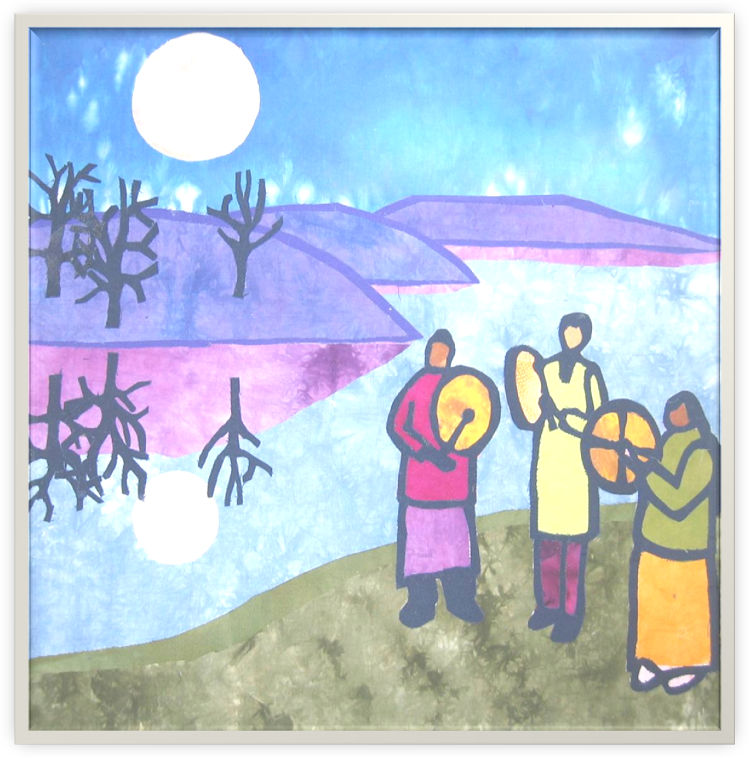 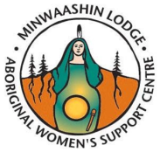

***You are invited to attend our***

***ANNUAL WOMEN'S GATHERING 2012***

**REVISED DATE: May 18 - 20th, 2012**

***Our Songs Are Our Prayers***

**Minwaashin Lodge - Aboriginal Women’s Support Centre**

**is hosting a women’s camping weekend in rural Ottawa.**

**Who:** All women 16 yrs + (Aboriginal and non-Aboriginal) are invited to join us in a healing weekend, sharing alternative healing methods and traditional Native teachings.

Experience traditional ceremonies, teachings and crafts. Discover alternative healings, while enjoying the natural setting and peaceful atmosphere of rural Ottawa.

**When:** Friday, May 18th - Sunday, May 20, 2012

**How Much:** $ 125.00 all inclusive weekend

For more information and or to register, please visit our website at: [**www.minlodge.com**](http://www.minlodge.com) or e-mail **gathering@minlodge.com**

***Respecting Women and Children is our Culture.***

This weekend is dedicated to health and well being.

No alcohol, illicit drugs or pets are allowed on the property.