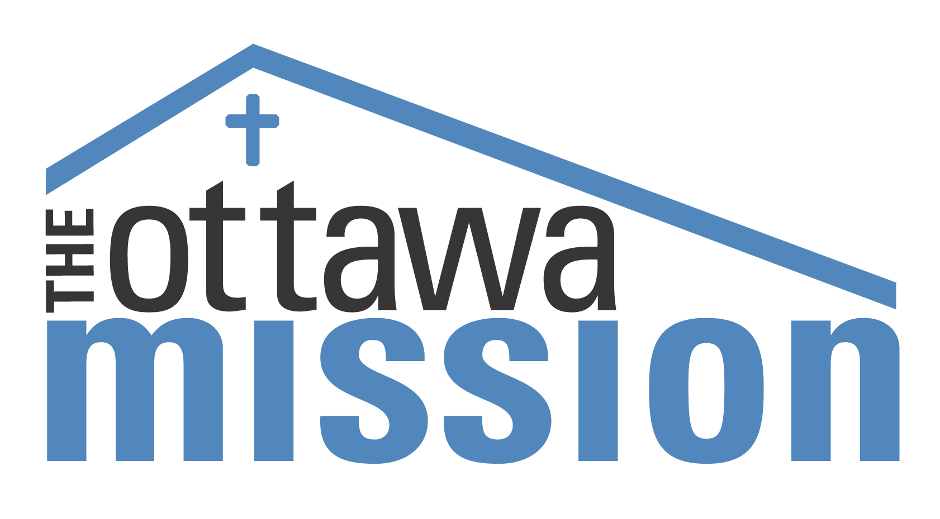
JOB POSTING

Job Title: Addictions Support Worker (1 Year Full Time Contract with the possibility of extension)
Department: Addiction Services
Reports To: Manager of Addiction Services

The Ottawa Mission is a non-profit, faith-based ministry, which has been evolving to meet the needs of the homeless and those at risk of being homeless in the Ottawa region since 1906. The Ottawa Mission responds to those in need with food, clothing and shelter, and has expanded its services dramatically in recent years to include life skills and training programs, education and job training programs, employment and housing services. On-site health services include a hospice, medical clinic and dental clinic. Our goal is to meet immediate physical needs, and be a place of transition where people in a vulnerable state can reach their potential with patience, understanding and God’s grace.

The Ottawa Mission runs a full continuum of addiction services, from drop-in harm reduction outpatient groups, to stabilization and long-term residential programs, as well as operating two transitional houses in the community for people in recovery from substance and behavioural addictions.

Position Purpose:
Reporting to the Manager of Addictions Services, the person in this position provides crisis intervention; assessments and intakes into all levels of addictions programming; facilitates psycho-educational groups; maintains a caseload; provides case management and individual counselling services; liaises with community partners; and contributes to the smooth operation of both outpatient and residential addictions programs within the shelter setting. Specific groups that will be conducted by this individual may include: Anger Management, Seeking Safety, and Relapse Prevention groups. This position is an evening position, and may include weekends. The position requires some flexibility in hours.

Duties and Responsibilities:
- Develop and build therapeutic rapport with clients in Addictions Services at The Ottawa Mission
- Complete intake process from screening and assessment through to admission
- Facilitate treatment groups and educational sessions
- Provide case management and individual counselling services to Dry Wing and Stabilization clients
- Liaise with community partners
- Maintain up to date files on all interaction with clients and provide Manager of Addiction Services with detailed monthly reports
- Attend Supervision/Team meetings as required on a weekly basis to review and engage in treatment strategies
- Provide support to Program Coordinators and the Manager of Addiction Services
- Perform other miscellaneous duties as assigned by the Manager of Addiction Services

Qualifications:
- Ability to work in a faith based environment whose values are acceptance, respect, compassion, integrity and interdependence
- University degree or College Diploma in Social Work, Addictions or equivalent
- Minimum of 1 year experience in an addictions treatment setting
- Experience in crisis counselling, individual counselling,0 and group facilitation
- Excellent communication skills both verbal and written
- A valid driver’s license is required
- Bilingualism (French and English) is an asset

Submission:
Send your resume by email to hr@ottawamission.com or by fax to 613-234-2813 by April 18, 2012. We thank those who apply, however, only those considered qualified for the position will be contacted.

