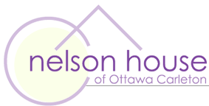

Notice of Annual General Meeting

Nelson House of Ottawa Carleton will be holding its annual general meeting on August 3, 2012. The meeting will be held between 4-6 pm at the Carlington Community Health Centre at 900 Merivale Rd. We will be bringing forward the auditors reports from 2011-2012, electing a new term Board of Directors and presenting a plan for moving forward with the re-opening of Nelson House.

All are welcome.
Please note that membership will be accepted at the door.

The Interim Board of Nelson House

