Job POSTING 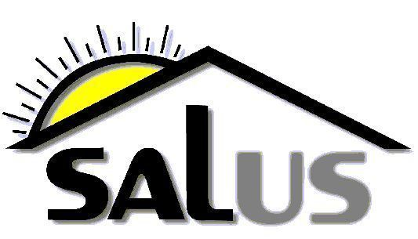
Ottawa Salus Corporation

POSITION: Community Developer ( 2 positions)
POSITION TYPE: Bilingual, full-time, 35 hours per week, permanent, unionized
Start Date: September 2012

The candidate for this position, which falls under the Community Development Program Manager, will be a member of a multidisciplinary team providing community mental health services and support to Ottawa area adults living with severe and persistent mental illness. The Community Developer works in collaboration with Ottawa Salus’ housing department as well as a diverse range of community partners and organizations. The goal of Salus Community Development is to foster health and wellness on an individual and community level within Salus’ housing portfolio and three designated Ottawa Community Housing buildings.

KEY RESPONSIBILITIES:
The key responsibilities of this position include but are not limited to the following:

- Provide recovery-based, client centred support to Salus tenants and tenant communities (and where applicable, OCH tenants and tenant communities)
- Identify and analyze tenant community needs
- Search for solutions to issues in collaboration with tenants and community partners
- Develop and / or foster partnerships with community agencies and tenants circles of care
- Motivate and support tenants in accessing programs and activities that support community integration and health and wellness
- Develop and facilitate programs and / or activities in line with community development objectives
- Work in collaboration with Salus housing and OCH to support tenants in resolving tenancy issues
- Carry out administrative and other responsibilities

QUALIFICATIONS:
- Bachelor’s degree
- Bilingual (French /English)
- 3 years experience in social services, community development or related field
- Experience working with marginalized and vulnerable individuals and communities
- Experience working with people who live with severe and persistent mental illness and/or addictions
- Experience with program development and facilitation
- Understanding of values related to community development and recovery in mental health
- Experience maintaining and fostering community partnerships
- Excellent interpersonal and communication skills
- Demonstrated skills in organizing, conflict resolution, advocacy and group facilitation
- Good working knowledge of Windows, Outlook Express and Internet Explorer
- Flexible hours may be required.

SALARY RANGE:
- $43,534.40 - $49,777.00

Please submit your cover letter and resume before 4:30pm, August 31st, 2012 to:

Tamara Chipperfield
Community Development Program Manager
Ottawa Salus
2000 Scott Street
Ottawa, On
K1Z 6T2

tchipperfield@salus.on.ca

We thank you for your interest but only candidates selected for an interview will be contacted.

