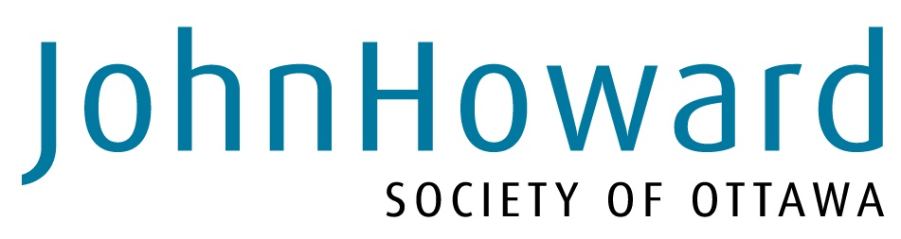

Job Advertisement

Title: Coordinator- Non Residential Attendance Centre
Department: Child and Youth Services
Location: multiple-site locations (Kanata and Vanier)
SALARY: range from 47,659 to 62,184
Employer: John Howard Society of Ottawa
How To Apply: By E-mail: rwootton@ottawa.johnhoward.ca
By fax: (613) 789-7431
Closing Date: please submit cover letter and resume for consideration by October 5th at 3pm 2012. Only those selected for an interview will be contacted

Summary
The NRAC program is a non-custodial sentencing option as identified in the Youth Criminal Justice Act. This program in Ottawa is a continued plan from the Youth Justice Division of the Ministry of Children and Youth Services to decrease reliance on custody and further intensive community-based interventions. The goal of this program is to support youth in reducing offending behaviour through targeted programs that are offered in both individual and group settings.

The scope of this position is to supervise a team of 3-4 staff and 1-2 students while carrying a reduced case load to support direct interventions with youth.

Education and Experience:
- Post-secondary degree or diploma in related field
- Minimum four years’ experience working with vulnerable populations; experience with youth an asset
- Experience in management, administration and/or coordination of a program that services clients

Languages: Fluency in English. Fluency in French will be considered a strong asset.

knowledge and Ability requirements
Successful candidates will:
- Have strong working knowledge and experience in the youth justice sector, and Youth Criminal Justice Act legislation
- Be committed to working within the core values of JHS Ottawa and supporting the team day to day in doing so
- Have experience with, and be committed to working with vulnerable and marginalized populations in a dignified and respectful manner
- Experience with effective group facilitation
- Proven experience with effective relationship building with community partners and referral source
- Have strong management and leadership skills to effectively lead a team
- Proven ability to work within a broader management team
- Be adaptable, extremely reliable, flexible and willing to work at multiple site locations (east and west end) including some early evening work
- Take initiative and ensure tasks are followed through to completion
- Be comfortable working within strict deadlines and under pressure
- Have strong organizational skills to support effective time management
- Demonstrated ability in fiscal and human resource management
- Demonstrated ability to work within established program, department and agency level protocols
- Represent program and agency with professionalism and integrity at all times
- Have Up-to-date clear Criminal Record Check/ vulnerable populations format

Program Coordinator- NRAC Program

Classification: Coordinator Salary Range: 47,659-62,184
Reports to: Department Director Effective Date: October 2012

Job Summary:
Under direction of the Department Director (DD), and Clinical Director (CD) the Coordinator of the Non-Residential Attendance Centre (NRAC) Program is responsible for the implementation and management of the NRAC program within Child and Youth Services of the John Howard Society of Ottawa, in accordance with site Protocols and Agency- level Operating and Personnel Policies and established Clinical Practices.

Principal Duties:

Programs and services
- Ensure adherence to the overall established service delivery model
- Provide interventions and programming based on service model (Coordinator to carry a reduced case load, which involves assessment and case planning, individual programming and group facilitation)
- Develop and maintain all forms associated with program
- Responsible for maintaining wait list
- Completing all necessary screening, intake and file assignments to counsellors
- Ensure review, analysis and evaluation of service effectiveness
- Maintain current knowledge of youth justice trends affecting service delivery
- In consultation with CD, promote the development of more effective services through service improvements/enhancements
- Prepare and submit to DD proposals, grants as required
- Initiate, develop, maintain and sustain relevant partnerships with other agencies
- Complete relevant partnership agreements, and ensure follow through on deliverables
- Complete service contracts and ensure follow through on deliverables
- Ensure follow through on agency Quality Assurance activities and outputs
- Ensure necessary quarterly statistics are compiled and submitted
- Review client reports and approve for submission to referral source
- Ensure that yearly program level targets are developed and implemented based on strategic priorities and plans of agency as well as funder agreements
- Operationalize, targets through work plans that include activities and subtasks
- Ensure work plan activities are completed within timelines and deadlines

Community relations
- Continue to build mutually beneficial relationships with referral source (probation and court system)
- Maintain cooperative working relationships with collateral agencies and service providers
- Ensure that youth referrals are handled in an effective and time-efficient manner
- Actively participate in committee work as it relates to justice issues
- Participate in opportunities to speak on behalf of the Society
- Represent Agency through presentations to the Board, community networks and committee meetings

Marketing/program promotion
- In consultation with DD develop program marketing strategy that falls within the agency strategy and keeps the program positive in the public eye
- Inform/keep DD aware of trends that influence/impact overall Department image
- Plan, implement, and evaluate effectiveness of all communications and marketing activities within program
- Attend relevant community sessions to speak on behalf of program

Human Resources
- Support the effective recruitment of personnel, in compliance with HR P&P.
- Support appropriate orientation and training of new employees, students, volunteers.
- Where appropriate, consult with DD and CD on in-service and external employee training
- Support effective supervision and evaluation of employees, students and volunteers
- Provide direct supervision to other relevant staff and volunteers, through annual performance appraisals and regular supervision meetings.
- In collaboration with DD ensure compliance with existing and newly developed operational and personnel policies, clinical practices and relevant legislative requirements

Financial management
- Work with DD to develop and review yearly program budgets
- Support funder’s budget submissions and prepare other funding applications as required.
- Review monthly financial statements for program to ensure efficient and effective fiscal management
- Monitor expenditures and ensure program is operating within its budget
- Comply with all fiscal tracking processes

Property management
- Oversee and ensure that the NRAC building and equipment is well-kept and safe
- Coordinate and organize with DD any renovations that are required
- Maintain compliance with municipal, provincial and federal codes that relate to physical building
- Ensure that an emergency preparedness plan is in place, and that all employees and clients are compliant
- Ensure safe work practices are followed and comply with all safety measures established in building
- Responsible for implementation and follow through of all protocols associated with NRAC program
- Responsible for overall maintenance of property at Vanier site

Administrative/Other
- Attend management meetings as scheduled
- Participate as required in Department strategic planning meetings
- Input on Department strategic priorities based on internal agency trends and external community trends
- Attend Board meetings as scheduled and provide presentations as required
- Attend supervision meetings with DD and CD required
- Complete other functions per DD and CD as requested

Job Specifications/Qualifications:
- Post-secondary degree or diploma in related field
- Minimum four years’ experience working with vulnerable populations; experience with youth an asset
- Experience in management, administration or coordination
- Proven, strong written and verbal communication skills
- Excellent organizational and interpersonal abilities
- Demonstrated leadership ability
- Demonstrated ability in fiscal and human resource management
- Demonstrated ability to work within established program, department and agency level protocols, policy and procedures

Disclaimer: This job description indicates the general nature and level of work expected of the incumbent. It is not designed to cover or contain a comprehensive listing of activities, duties or responsibilities required of the incumbent. Incumbent may be asked to perform other duties as required.

