2012 FINANCIAL SPONSORSHIP OPPORTUNITIES

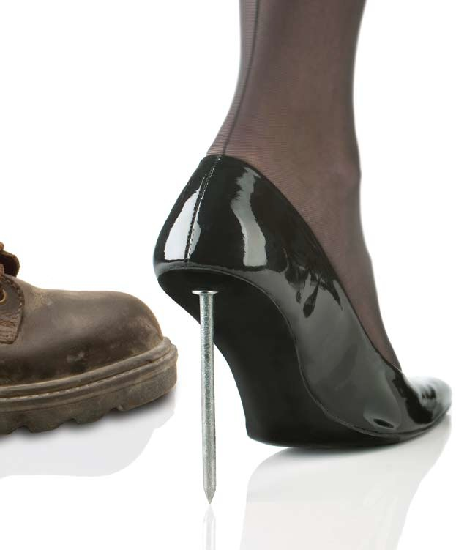

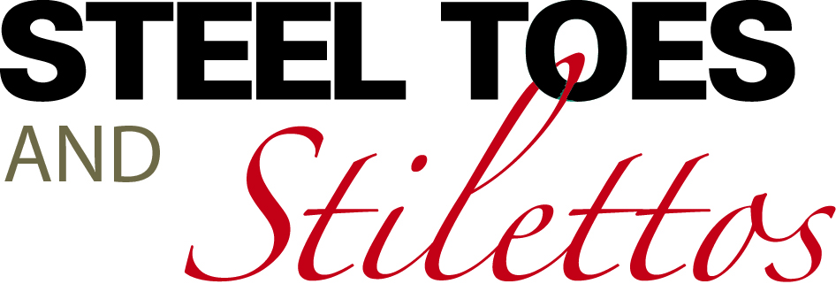

GALA EVENING

**Saturday, October 20, 2012**

**The Westin Ottawa**

**Reception: 6 p.m. Dinner: 7 p.m.**

Please join us to celebrate our **7th Annual Habitat for Humanity NCR Steel Toes and Stilettos Gala**. This will be an elegant and fun-filled evening with fabulous fashions by Shepherd’s and ER Fisher, dinner, dancing and exciting live and silent auctions. This year’s theme is *“Dancing with Fashion”* and our hairstylist of choice is Destination Hair. Once again, our Honorary Gala Patrons are the U.S. Ambassador David Jacobson and his wife, Julie Jacobson and our Emcee will be Carol Anne Meehan, CTV Ottawa News Anchor.

Habitat NCR is a volunteer, non-profit organization that builds simple, decent, affordable homes and sells them with no-interest mortgages to low-income, working families seeking an affordable home in which to raise their children. Since 1993, Habitat NCR has built 38 homes, completed seven retrofits and housed more than 50 families in the National Capital Region. To learn more, visit: [**www.habitatncr.com**](http://www.habitatncr.com)

**DIAMOND SPONSOR $15,000**

• Category exclusivity and first right of refusal for 2013 Gala;

• Acknowledgement as lead sponsor on all communications, including media releases and print material, such as ads, postcards, posters, programs, etc.;

• Acknowledgement as lead sponsor on the Habitat NCR website and all Habitat NCR social media channels;

• Acknowledgement as lead sponsor in HabiChat, our e- newsletter distributed bi-monthly to 7,000 people;

• Logo on inside front cover of Gala program and full page advertisement in the program;

• Logo projected on big screen at the Gala;

• Opportunity to extend corporate greetings during the Gala;

• Two (2) VIP invitations for the Gala head table;

• One (1) corporate table for eight along the runway;

• Four (4) VIP invitations to the Pre-Gala reception at the home of the U.S. Ambassador on September 27th.

IN SUPPORT OF:



**EMERALD SPONSOR $10,000**

• Company name and logo in all communications, including media releases and print material, such as ads, postcards, posters, programs, etc.;

• Company name and logo on Habitat NCR website and all Habitat NCR social media channels;

• Company name and logo in HabiChat, our e-newsletter distributed bi-monthly to 7,000 people;

• Logo on inside front cover of Gala program and half-page advertisement in the program;

• Logo projected on big screen at the Gala;

• One (1) corporate table for eight;

• Four (4) VIP invitations to the Pre- Gala reception at the home of the U.S. Ambassador on September 27th.

**RUBY SPONSOR $5,000**

• Company name and logo in all communications, including media releases and print material, such as ads, postcards, posters, programs, etc.

• Company name and logo on Habitat NCR website and all Habitat NCR social media channels;

• Company name and logo in HabiChat, our e-newsletter distributed bi-monthly to 7,000 people;

• Logo on inside front cover of Gala program and quarter-page advertisement in the program;

• Logo projected on big screen at the Gala;

• Four (4) tickets to the Gala;

• Two (2) VIP invitations to the Pre-Gala reception at the home of the U.S. Ambassador on September 27th.

**SAPPHIRE SPONSOR $2,500**

• Company name and logo in all communications, including media releases and print material, such as ads, postcards, posters, programs, etc.

• Company name and logo on Habitat NCR website and all Habitat NCR social media channels;

• Company name and logo in HabiChat, our e-newsletter distributed bi-monthly to 7,000 people;

• Logo on inside front cover of Gala program and business card advertisement in the program;

• Logo projected on big screen at the Gala;

• Two (2) tickets to the Gala;

• Two (2) VIP invitations to the Pre-Gala reception at the home of the U.S. Ambassador on September 27th.

IN SUPPORT OF:



GALA EVENING

**Saturday, October 20, 2012**

**The Westin Ottawa**

**Sponsorship Confirmation**

**Please complete and return by email to:** [**fundraising@habitatncr.com**](mailto:fundraising@habitatncr.com) **or by fax to: 613-749-8991 before September 1st.**

**Yes, our company wants to be the:**

___**Diamond Sponsor** @$15,000 ___**Ruby Sponsor**  @$5,000

___**Emerald Sponsor** @$10,000 ___**Sapphire Sponsor** @$2,500

Company Name: ­­­­­­­­­­­­­­­­­­­­­___________________________________________________________

Contact Name & Title: ______________________________________________________

Address: _________________________________________________________________

City:____________________Province:__________________Postal Code:_____________

Telephone:_______________Fax:__________________E-mail:______________________

**PLEASE NOTE:**  Your company/organization will be invoiced upon receipt of your confirmation form.

Cheques should be made payable to: **Habitat for Humanity National Capital Region.**

**FOR INFORMATION:**  Call **Gail Logan**, Community Engagement Manager at: **613-749-9950, ext. 223** or e-mail to: [**fundraising@habitatncr.com**](mailto:fundraising@habitatncr.com)**.**

**CHARITABLE REGISTRATION #:** 140290 735 RR0001

**IN SUPPORT OF:**