Learn about the
Registered Disability Savings Plan (RDSP)
Hosted by
Ottawa Independent Living Resource Centre

The RDSP is designed to help people with disabilities and
their families save for the future.
You should consider opening an RDSP if you have a long-term disability and are:

- under age 60 (you must apply before the end of the calendar year in which you turn 59 years old);
- a Canadian resident with a Social Insurance Number (SIN);
- eligible for the Disability Tax Credit; and
- looking for a long-term savings plan.

- To help you save, the Government will pay a matching Canada Disability Savings Grant of up to $3,500 a year on your contributions.

- The Government will also pay a Canada Disability Savings Bond of up to $1,000 a year into the RDSPs of low-income and modest-income Canadians.

- No contributions are necessary to receive the Bond. Grants and Bonds are paid into the RDSP until the end of the calendar year in which you turn 49 years old.

- Money paid out of an RDSP will not affect your eligibility for federal benefits, and will have little or no impact on provincial social assistance payments.

Join us at the following information sessions:
Date: Thurs. Dec. 13  Time: 7:00-8:30pm  Location: Ottawa Independent Living Resource Centre  214 Montreal Rd  Suite 401 | Date: Wed., Jan. 09  Time: 7:00-8:30pm  Location: Ottawa Public Library –  50 Castlefrank | Date: Tues., Jan. 29  Time: 7:00-8:30pm  Location: Ottawa Public Library – Ruth E. Dickinson Branch  100 Malvern

For more information or to register, please contact Sasha Gilchrist
at 613-236-2558 ext. 227 or by email at Sasha-ileap@oilrc.com
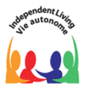
This information session is available in English only.
Special Accommodations available upon request.

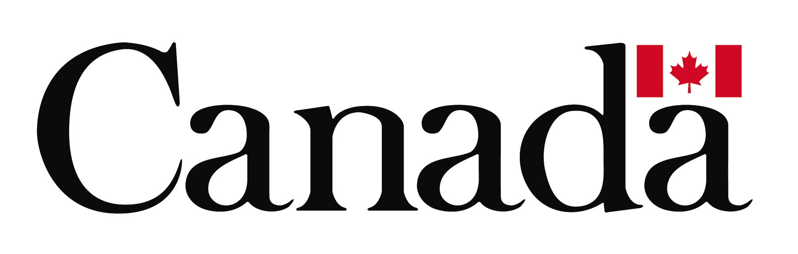
Afin d'obtenir des renseignements en français, veuillez communiquer avec
Julie Belleau-Hibbard par téléphone au: 613-563-2581 poste 13 ou par
courriel à: rdsp-reei@ilc-vac.ca, ou visitez: www.vacanada.ca

Funding for these information sessions is provided by the Government of Canada.

