Centre 507 Association of Ottawa Annual General Meeting

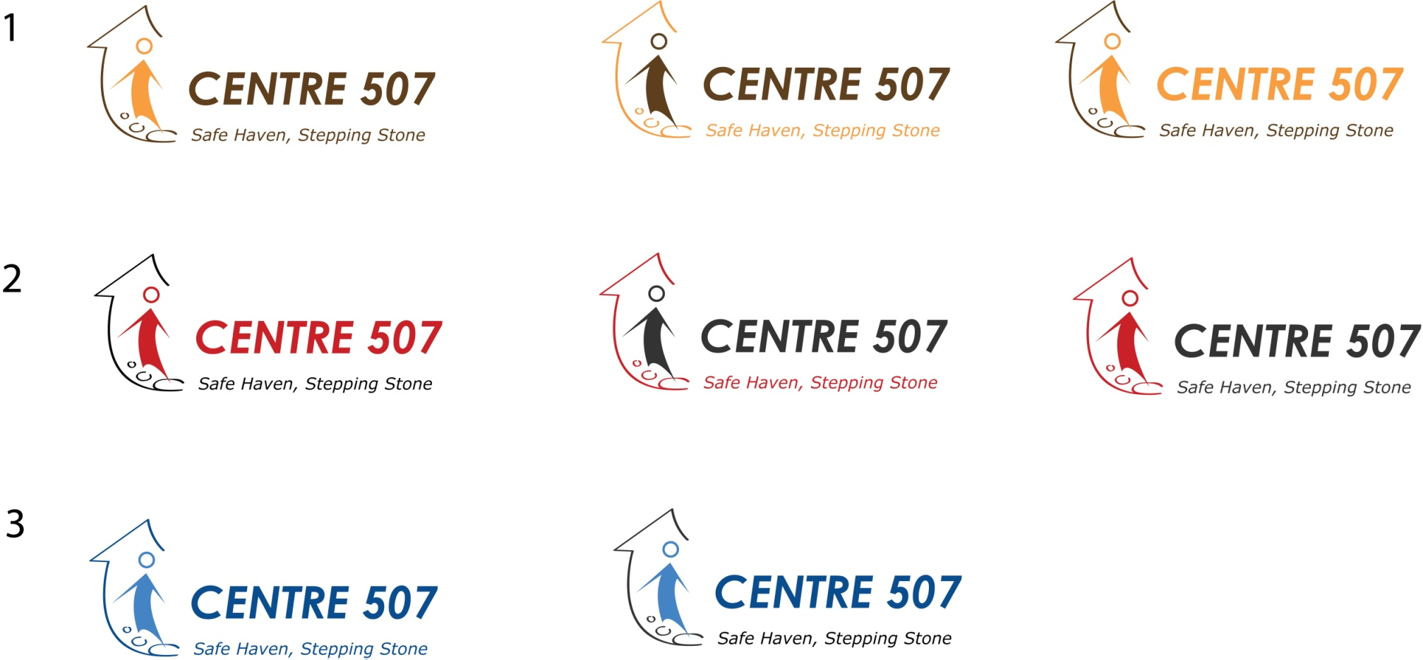

**MARKING THIRTY YEARS OF SERVICE**

* Members and Friends are

cordially invited to attend

* April 30th, 2013 at 7:00 pm
* 507 Bank Street on the 2nd floor of

Centretown United Church

**Join us in recognizing and thanking some of**

**the many partners, facilitators and friends**

**who support the ongoing work of**

**Centre 507’s programs and participants**

**Mayor Jim Watson will be saying a few words to us**

**Light snacks and refreshments will be provided.**