**A Different Street Housing**

**Open-House**

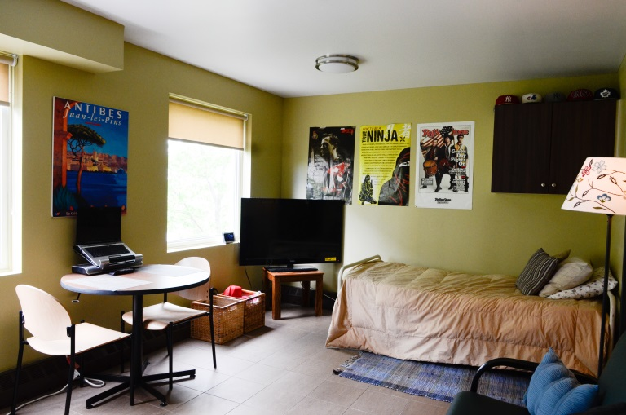

**Join us in celebrating our newly renovated building and see the new bachelor units, common space for youth and meet and greet with staff….**

A Different Street Housing provides affordable housing and support services to young men, ages 16 to 21, who are at-risk or have current/past justice-involvement and are homeless/unsuitably housed. ADS provides short-term and long-term bachelor apartments to male youth.

**June 25th**

**3pm-5pm**

**308 Cambridge Street North**