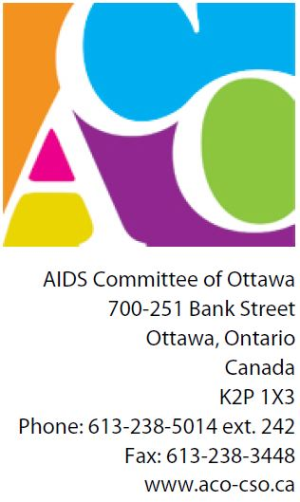**Forum Registration**

Real Issues-Real Solutions:   
a Closer Look at HIV and the Criminal Justice System

Forum Date: September 27, 2013

Location: RA Centre Ottawa, 2451 Riverside Drive, Ottawa ON

**Attendee Information**

|  |  |
| --- | --- |
| Name: |  |
| Name (2): |  |
| Name (3): |  |
| Name (4): |  |
| Organization: |  |
| Address: |  |
|  |  |
| Postal Code: |  |

|  |  |
| --- | --- |
| Dietary Requests: |  |

**Registration Fees**

|  |  |
| --- | --- |
| Forum Fees: | $25.00 |
| Number of Attendees: |  |
| Total: |  |
| Payment can be made by cash or cheque.   Please make cheque out to ‘AIDS Committee of Ottawa’  Mail to: AIDS Committee of Ottawa ATTN: Caleb Chepesiuk, 700-251 Bank St, Ottawa ON K2P 1X3 |  |