

**Come celebrate Mental Health Week!**

The Canadian Mental Health Association, Ottawa Branch

Invites you to a breakfast and presentation

**“Stigma and the Mental Health Professional”**

By Dr. Heather Stuart, Bell Canada Mental Health and

Anti-Stigma Research Chair, Queen’s University

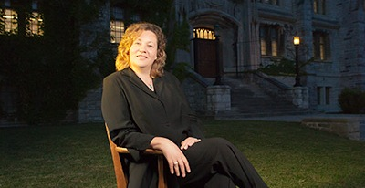

**Wednesday May 7, 8:30 a.m.-9:30 a.m.**

**R.A. Centre, Clark Hall**

**2451 Riverside Dr, Ottawa, ON K1H 7X7**

**No charge, reservation required.**

**Please contact Donna-Lynn Perron,** [**dperrin@cmhaottawa.ca**](mailto:dperrin@cmhaottawa.ca) **613-737-7791**