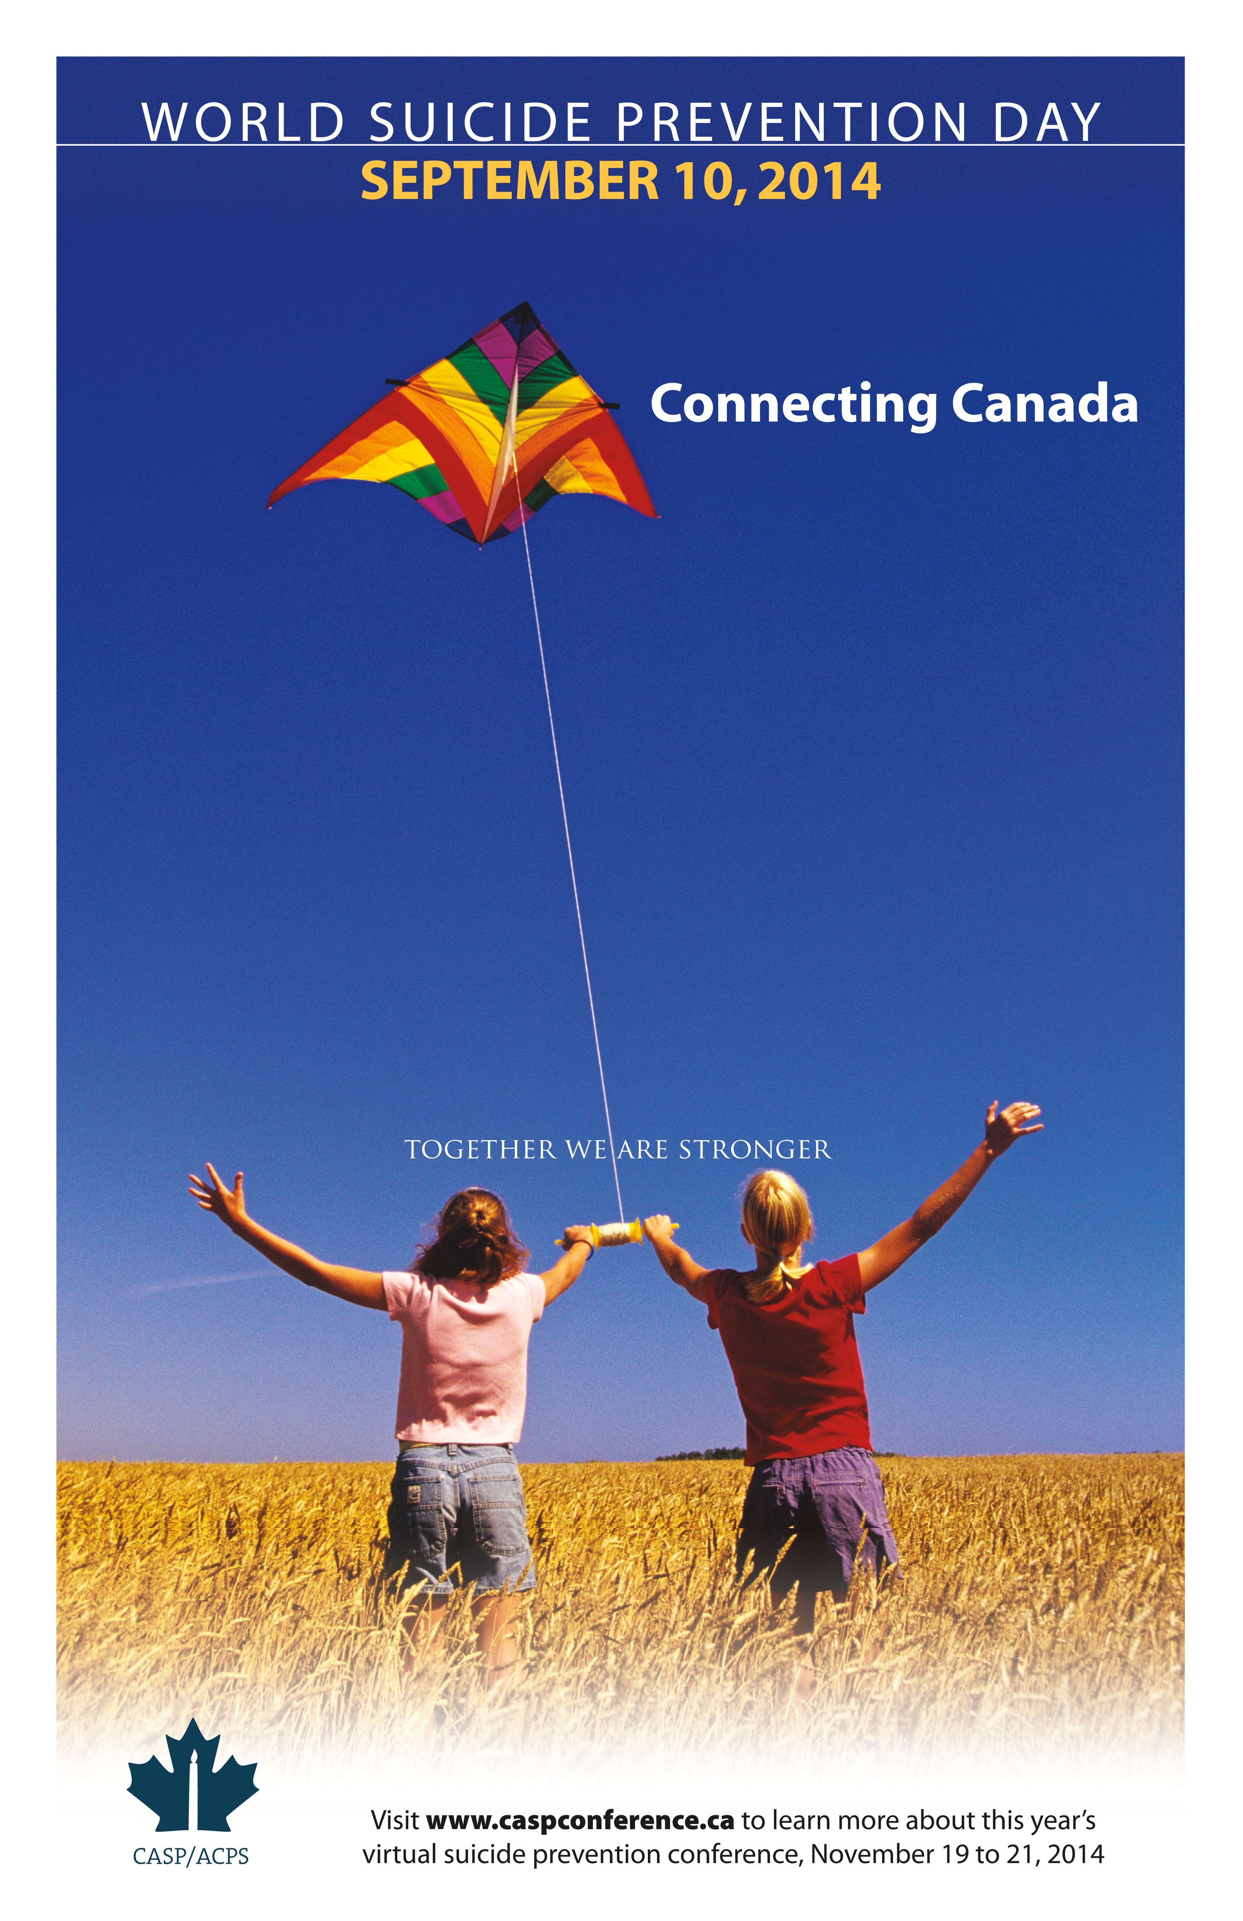

**A Breakfast Conversation on Suicide Prevention**

**Research, Resources and Best Practices**

**The Ottawa Suicide Prevention Coalition is hosting a free breakfast discussion on suicide research, resources and best practices on September 10th , 2014 from 8:00 to 10:00 am at the RA Centre , 2451 Riverside Drive in the Clark Hall.**

**Participants will hear from renown researcher Dr. Ian Colman, Canada Research Chair in Mental Health Epidemiology and Associate Professor at University of Ottawa, Renée Ouimet, President of the Canadian Association for Suicide Prevention and Director of Capacity Building and Education at CMHA, Ottawa.**

**Registration and breakfast from 8:00-8:30 am**

**Please register by calling CMHA, Ottawa at 613 737-7791 by September 2nd, 2014**

**Conversation on Suicide** Prevention

Research, resources, and best practices

A