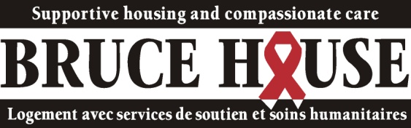

July 2014

**Member of the board of directors**  
  
Bruce House is looking for volunteers to serve on its board of directors. Individuals who have experience in finance, governance, social services, and organizational and change management, as well as individuals seeking an opportunity to improve the lives of Bruce House clients regardless of their experience are invited to apply.

Founded in 1988, Bruce House is a community-based organization that provides housing, compassionate care and support for people in Ottawa living with HIV and AIDS, based on the belief that everyone has the right to live and die with dignity.  
  
We achieve our mandate through our Transition House Program—for people living with HIV/AIDS who require high levels of care and support—and through our Apartment Program (Supportive Independent Living Program)—where people living with HIV/AIDS are provided with rent-geared-to-income housing, along with counselling, coaching and other kinds of support.  
  
The board positions are two year terms beginning in September 2014, and are renewable for another two terms of two years.  
  
The 11-member volunteer board of directors usually meets on a monthly basis. In addition to attending monthly meetings and contributing to sound organizational decision-making, board members are expected to serve on Bruce House committees, provide support with fundraising, help with program activities and work with Bruce House's executive director in setting policies and strategic objectives, providing professional counsel and assessing organizational progress.

Bruce House supports the greater involvement of people living with HIV/AIDS and encourages people living with HIV/AIDS to apply.  
  
Interested? Please send a covering letter outlining your experience, interests and expertise, and a copy of your résumé in confidence to [**nominations@brucehouse.ca**](mailto:nominations@brucehouse.ca)  on or before 3 September 2014.