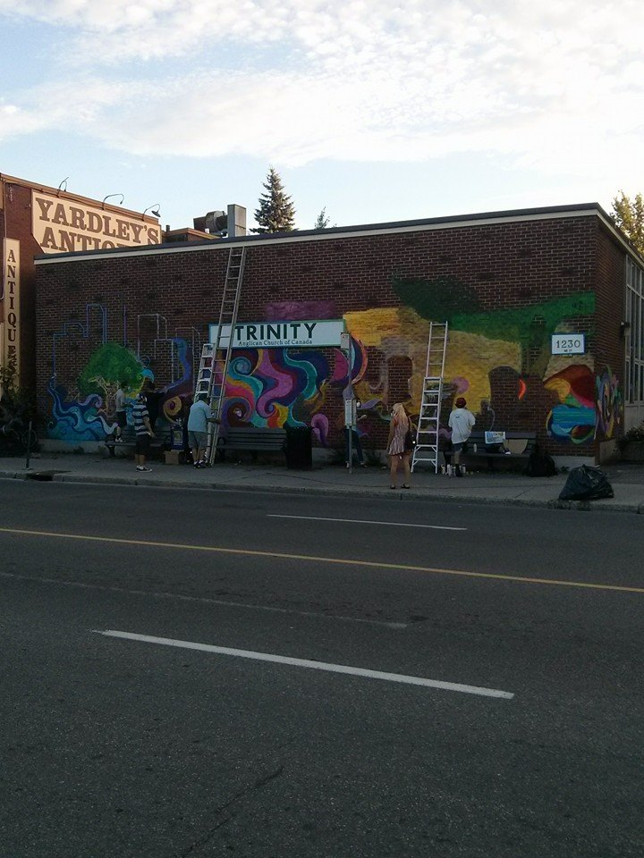

***The mural in progress...come check out the finished product at the unveiling!***

**Community Mural Unveiling Ceremony**

**Wednesday, September 3rd, 7 p.m.**  
1230 Bank St. (Corner of Bank/Cameron)

Join Trinity Anglican Church, House of PainT and Ottawa Innercity Ministries for our mural unveiling! In addition to celebrating beautiful graffiti art, we are celebrating community in Old Ottawa South, and the launch of House of PainT’s 11th Annual Hip Hop Festival, September 4th-7th.

This mural was made possible through a generous grant from Crime Prevention Ottawa’s Paint It Up program, which uses urban arts to empower youth.

**THANK YOU** to our neighbours at Hillary’s Dry Cleaners for donating their parking lot for the unveiling ceremonies.

