EMPLOYMENT OPPORTUNITY

The Salvation Army
Ottawa Booth Centre
 | 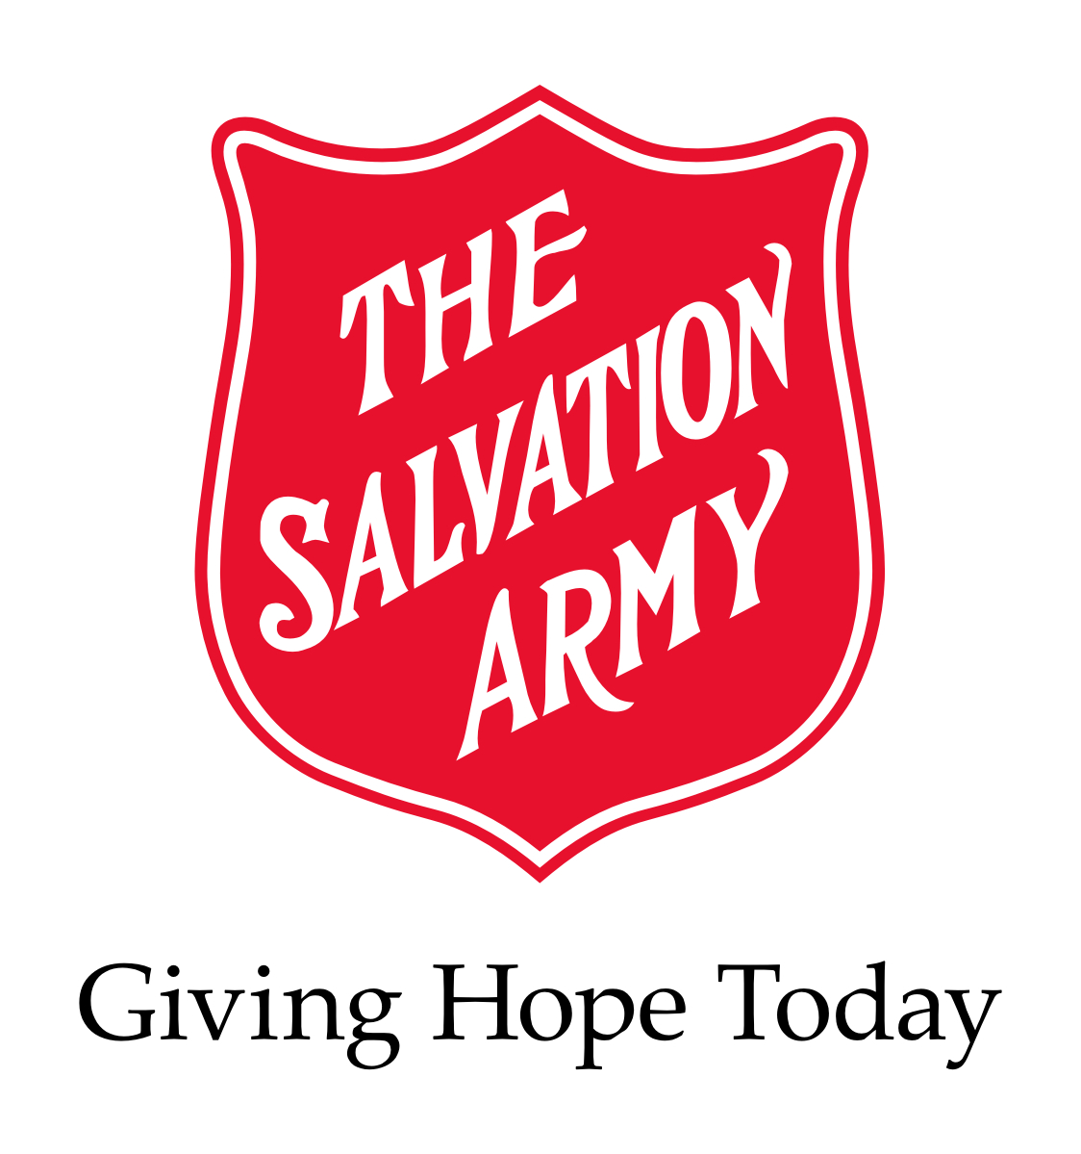
POSITION: | Addiction Counsellor (1) Full Time Position  September 11th, 2014  Job Posting #43/14
FACILITY: | The Salvation Army, Ottawa Booth Centre
LOCATION: | 171 George St. Ottawa, ON. K1N 5W5

RESPONSIBILITIES:

Counselling (Using the CRA Model)
- Completes screening and assessments of potential clients, determining suitability to the Anchorage program or, when necessary, referral to other more appropriate programs
- Incorporate information obtained through the assessment process and comprehensive treatment/recovery plan to inform the counselling approach
- Establish a helping relationship with the client, characterized by warmth, respect, genuineness, concreteness and empathy
- Offers counselling to clients / candidates in crisis and makes referrals to other resources as required
- Assumes an assigned caseload, as primary addictions care giver, using a case management system
- Records in log and case notes in an accurate and clear manner, shares at case management sessions any observations and information regarding each client’s progress
- Support clients in the further development of treatment /recovery plans
- Facilitate group sessions using the CRA model and components
Spiritual Guidance
- Attends daily devotions and chapel services in support of clients
- Supports spiritual guidance to clients in accordance with the Anchorage Mission Statement and Statement of Counselling Philosophy
Community Relations
- Provides liaison with outside service agencies such as Correctional Dept., Detox, Lawyers, etc.
- Provides program information to inquiring agencies, professionals, and applicants
Program Support
- Updates data base with client information for statistical purposes
- Administers toxicology tests to clients
- Administers to a variety of client requests and maintains records on such requests (e.g.) clothing vouchers
- Organizes / participates in certain program functions such as outings, graduations, fundraisers, etc.
- Ensures documentation is complete, accurate, and up to date

QUALIFICATIONS:
- Certification in Substance Abuse Counselling
- Experience working with a marginalized population as an addictions counsellor
- Proven working knowledge of the Community Reinforcement Approach
- Proven skill in the use of motivational interviewing and other cognitive behavioral therapies
- Experience in group facilitating
- Ability to recognize and work within professional and personal limitations and boundaries
- Proven ability to work successfully in a team environment
- Good organizational skills
- Pass an internal police background check (BackCheck); Note: A satisfactory criminal background check is required
- Bilingualism is an asset

SALARY: $19.49 (uncertified) or $21.04 (certified) per hour / 40 hours per week

HOURS OF WORK: Monday to Friday (8:00am – 4:30 pm.)

Interested applicants must respond in writing by Tuesday September 17th, 2014
Patty Rino
EMAIL:jobs@ottawaboothcentre.org

INTERNAL APPLICANTS: Your management supervisor must be aware of your intentions prior to submitting your application for this position

We thank all applicants, however, only those candidates to be interviewed will be contacted.

PLEASE NO PHONE CALLS

