

**Come celebrate our new**

**Community Appreciation Awards!**

You are invited you to a breakfast, award presentation and keynote:

**“One Health, One Welfare - The impact of community collaboration:**

**How the health of humans, animals and the environment are inextricably interconnected.”**

By **Dr. Michelle Lem, founding director of Community Veteran Outreach**

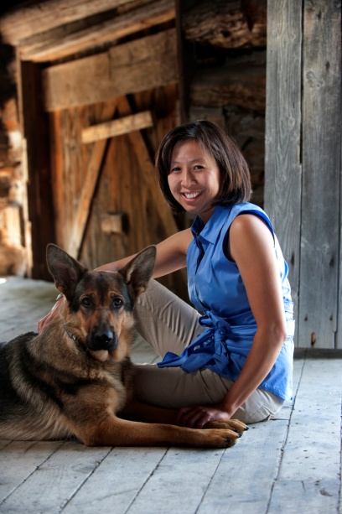

**Tuesday, Oct 7, 8:30 a.m.-10:30 a.m.**

**R.A. Centre, Clark Hall**

**2451 Riverside Dr, Ottawa, ON K1H 7X7**

8:00 - 8:30 a.m. Registration and continental breakfast

8:35 - 9:30 a.m. Presentation by Dr. Lem

9:30 a.m. Presentation of Community Appreciation Awards

**No charge, register with Donna-Lynn Perrin before Oct. 3**

[**dperrin@cmhaottawa.ca**](mailto:dperrin@cmhaottawa.ca) **613-737-7791**