EMPLOYMENT OPPORTUNITY

The Salvation Army
Ottawa Booth Centre
 | 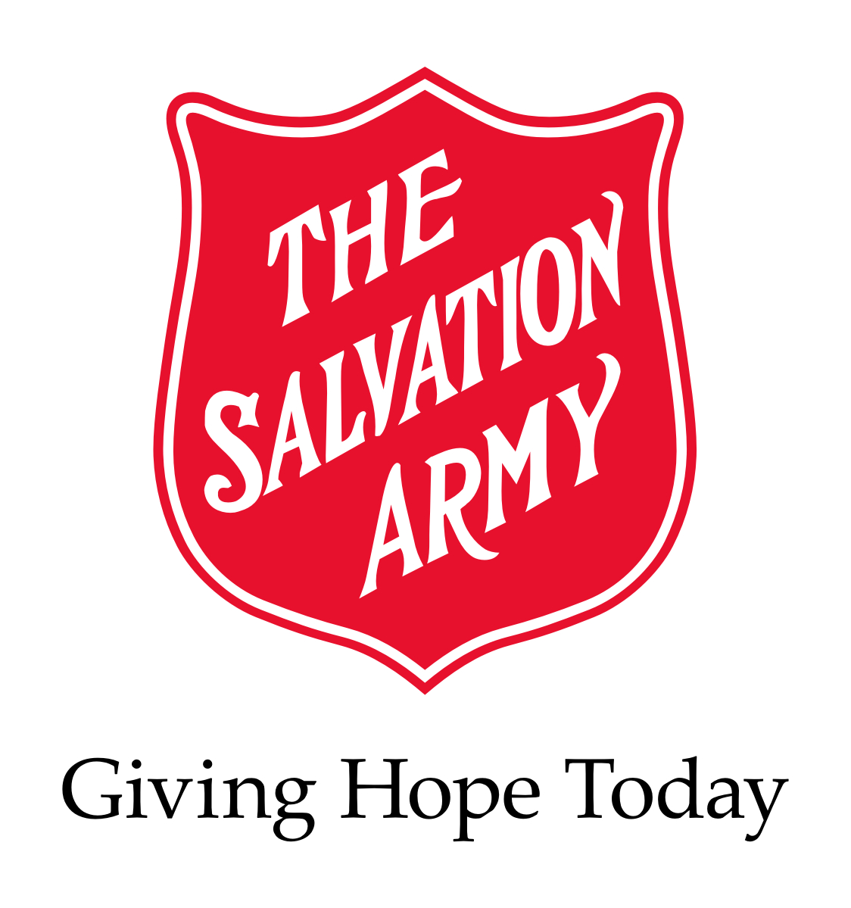
POSITION: | Addiction Counsellor for Stabilization Unit  (2) Full Time Position Unionized  January 5th, 2015  Job Posting #1 /15
FACILITY: | The Salvation Army, Ottawa Booth Centre
LOCATION: | 171 George St. Ottawa, ON. K1N 5W5

RESPONSIBILITIES:

Program Evaluation
- Participates in the development and implementation of program content and policies
- Participates in the program evaluation

Group Work (Using the CRA Model)
Facilitates group sessions as scheduled in the following program components:
- One to One Counselling Sessions
- Life-skills Classes
- Cognitive Restructuring Classes
- Anger Management Classes
- Mood Monitoring Classes
- Emotional Health Classes
- Relationship Skills Classes
- Relapse Prevention Classes

Individual Counselling (Using the CRA Model)
- Completes screening and assessments of potential clients, determining suitability to the Anchorage program or, when necessary, referral to other more appropriate programs
- Incorporate information obtained through the assessment process and comprehensive treatment/recovery plan to inform the counselling approach
- Establish a helping relationship with the client, characterized by warmth, respect, genuineness, concreteness and empathy
- Offers counselling to clients / candidates in crisis and makes referrals to other resources as required
- Assumes an assigned caseload, as primary addictions care giver, using a case management system
- Records in log and case notes in an accurate and clear manner, shares at case management sessions any observations and information regarding each client’s progress
- Support clients in the further development of treatment /recovery plans

Community Relations
- Provides liaison with outside service agencies such as Correctional Dept., Detox, Lawyers, etc.
- Provides program information to inquiring agencies, professionals, and applicants

Program Support
- Facilitate client accountability and complete discharges when necessary
- Administration, ordering and documentation of client medications
- Updates data base with client information for statistical purposes
- Administers toxicology tests to clients
- Administers to a variety of client requests and maintains records on such requests (e.g.) clothing vouchers
- Organizes / participates in certain program functions such as outings, graduations, fundraisers, etc.
- Ensures documentation is complete, accurate, and up to date

QUALIFICATIONS:
- Completed relevant undergrad university degree (eg Social Work, Clinical Counseling, Addictions)
- Current certification with the CACCF or the ability to obtain certification within 6 months of hiring
- Experience working with a marginalized population as an addictions counsellor within the last 5 years
- Ability to meet core competencies for the position of addictions counselor as outlined by the Champlain LHIN
- Proven skill in the use of motivational interviewing and other cognitive behavioral therapies
- Experience in the delivery and or development of psycho-educational programming and therapeutic groups.
- Ability to recognize and work within professional and personal limitations and boundaries
- Proven ability to work successfully in a team environment
- Pass an internal police background check (BackCheck); Note: A satisfactory criminal background check is required
- Bilingualism is an asset

SALARY: $19.49 (uncertified) or $21.04 (certified) per hour / 40 hours per week

HOURS OF WORK: Monday to Friday (8:00am – 4:30 pm.)

Interested applicants must respond in writing by January 19th, 2015
Patty Rino
EMAIL:jobs@ottawaboothcentre.org

INTERNAL APPLICANTS: Your management supervisor must be aware of your intentions prior to submitting your application for this position

We thank all applicants, however, only those candidates to be interviewed will be contacted.

PLEASE NO PHONE CALLS

