

**Come celebrate Mental Health Week!**

The Canadian Mental Health Association, Ottawa Branch

Invites you to a light breakfast and presentation

**“I don’t want to talk about it”**

**Men and Mental Health**

(Bilingual)

By **Jacques Legault**, C. Psych., Gatineau

Specializing in Men’s Mental Health

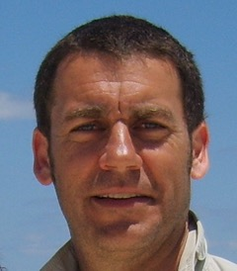

**Friday May 8, 2015, 8:30 a.m.-10:00 a.m.**

**R.A. Centre, Clark Hall**

**2451 Riverside Dr, Ottawa, ON K1H 7X7**

**No charge, reservation required.**

**Please contact Donna-Lynn Perrin,** [**dperrin@cmhaottawa.ca**](mailto:dperrin@cmhaottawa.ca) **613-737-7791**