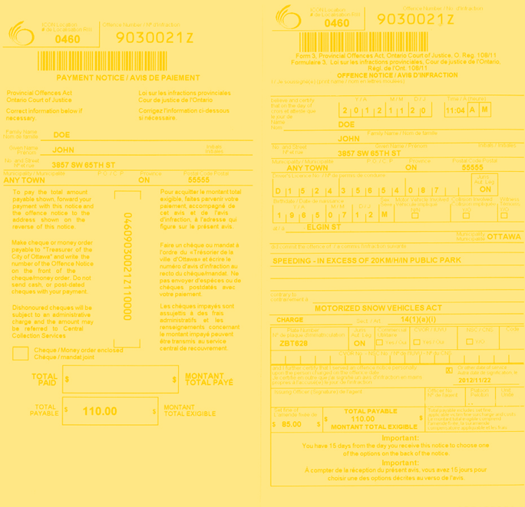An initiative of the ‘Support Don’t Punish’ Campaign

Get help with tickets issued through:

**Join Us for FREE FOOD!**

**And learn about the:**

* **Ticket Defense**

**Program**

* **Participatory**

**Research in Ottawa: Understanding Drugs (PROUD)**

* **Support Don’t**

**Punish Campaign**

* **Petition to Repeal**

**the Safe Streets Act**

**\*This is a public space – police and media may be there – please take care of yourself in deciding to attend this event**

**\*Have a question or need transportation help? Call Lindsay:**

**613-233-4443 x 2131**

• Liquor Licence Act

• Safe Streets Act

• Trespass to Property Act

• OC Transpo

• City of Ottawa Bylaws

**Bring Your Tickets to Minto Park!**

Receive legal info and representation!

Stand up against tickets that

target people in poverty!

**Thursday June 25th at 1 pm**

(Minto Park is across from

Jack Purcell at Elgin & Gilmour)

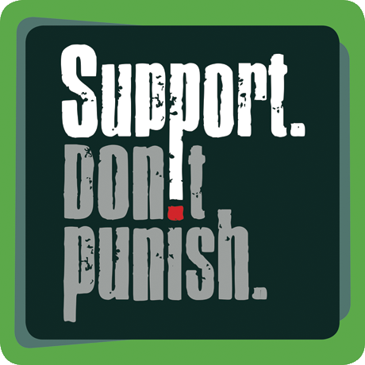

In partnership with

Centretown Community Health Centre,

Somerset West Community Health Centre (NESI), AIDS Committee Ottawa, PROUD, & the Ticket Defense Program