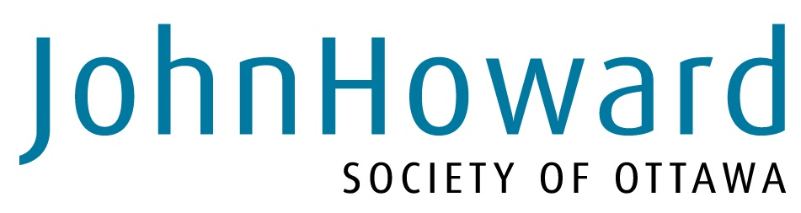

Job Posting

This is both an internal and external job posting.

Position: full time caseworker- A Different Street Supportive Housing
This is a contract position for six (6) months. The contract concludes 31, March 2016. There is the potential for renewal in the next fiscal year.

Department: Child and Youth Services
Salary: $40,357 to $52,657
Employer: John Howard Society of Ottawa
How To Apply: ATT: Rhea Wootton, Director of Administration
By E-mail: rwootton@ottawa.johnhoward.ca
By fax: (613) 789-7431
Closing Date: Wednesday September 9th at 4pm
** please submit full cover letter and updated resume by deadline. Only those selected for an interview will be contacted.

Summary
A Different Street Supportive Housing Program provides accommodation and support to 25 young men, ages 16 and up, who are justice-involved and homeless, or at risk of being so. The John Howard Society of Ottawa and youturn are partners in this program.

Utilizing a housing first approach, ADS provides male youth, regardless of their complexities and challenges, an opportunity to access safe accommodations and utilize intensive on-site supports to assist with their life goals. This program strives to contribute to a reduction in the number of individuals using homeless shelters, living on the street, or unstably housed, as well as to intervene with justice-involved and at-risk youth to decrease their risk for future offending and other problematic behaviours.

Candidate Requirements:

Education:
- University Degree/College Diploma in the social sciences

Experience:
- Minimum 2 years working with youth
- Counselling reluctant/court- ordered youth

Knowledge and Skills:
- Thorough understanding and experience applying Cognitive Behavioural, Social Learning, and Social Ecological approaches
- Thorough understanding and experience in the use of Motivational Interviewing
- Understanding of and experience working with clients that struggle with addictions, aggression, criminality and mental health issues
- Understanding of Housing First Principles
- Understanding of the Collaborative Problem Solving model
- Understanding of the theory and application of effective correctional interventions
- Familiarity with the Youth Criminal Justice Act and other relevant legislation (e.g., Child and Family Service Act, Mental Health Act)
- Competency in using criminogenic risk/need assessment instruments
- Basic understanding of the application of research to program design
- Bilingual preferred

Successful candidates will:
- Have an updated clear Criminal Record Check working with a vulnerable population
- Have a demonstrated ability to work as part of a cohesive team unit
- Have an interest working within a structured clinical model
- Have strong rapport building skills in engaging youth
- Have their own reliable vehicle for working with clients in the community
- Possess a strong commitment to working in this challenging but rewarding program
- Be willing to work some evenings
- Have excellent people skills to facilitate relationships with clients, colleagues, supervisors, program partners and community members
- Have a genuine interest in working with youth in a caring and empathic manner

All qualified individuals are welcome to apply.
Only those who meet all requirements will be considered for an interview.

*internal JHS candidate home positions may be held for the duration of this contract pending supervisor consultation

