**ID Needed to Vote in the Federal Election**

**October 19th 2015**

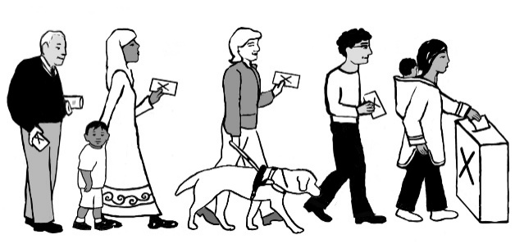

**Who can vote?**

* You must be a Canadian citizen
* You must be at least 18 years of age on election day
* You must prove your identity and address.

**What ID do I need?**

1. Show one piece of ID that has your name and current address (e.g. driver's licence, provincial or territorial ID card, any other government card with your photo, name and current address).

Or

1. Show two pieces of ID (full list on back). One must have your address, the other your name. The IDs cannot show 2 different addresses. A Health Card, hospital card, Government mail, prescription bottle, OW/ODSP info are considered valid ID if your name is on it.

Or

1. If your ID does not have your current address, take an oath. Show **two** pieces of ID with your name and have someone who knows you attest to your address. This person must show proof of identity and address, be registered in the same polling division, and attest for only one person.

**Homeless or without ID?**

**You can still vote!**

1. **Prove your identity:** Get your OW/ODSP drug card or payment statement. You can ask your worker or the shelter where you have recently stayed for this. Also, a pill bottle, prescription, health card or hospital card counts as ID if your name is on it. Ask your pharmacy or doctor to help you get this ID.
2. **Prove your address:** You can get a “Letter of Confirmation of Residence” from an agency where you sleep or one from where you eat. Ask a worker there for one! They can download this form from the Elections Canada website. www.elections.ca/id/EC50053_e.pdf
3. **Vote at the right place:** The address on your “Letter of Confirmation of Residence” is your riding. Ask the agency staff to look up your polling station. Bring your ID to either your Advance Polling Station from October 9th-12th or the regular polling station on October 19th.

**For more information, contact the Elections Canada at 1-800-463-6868.**

**ID needed for the 2015 Federal Election**

1) Show **one** of these pieces of ID (not expired)

•your driver's licence

•your provincial or territorial ID card

•any other government card with your photo, name and current address

2) Or, show **two** pieces of the following ID (At least one must have your current address):

|  |  |
| --- | --- |
| •health card | •card issued by an Inuit local authority |
| •Canadian passport | **•Canadian Forces identity card** |
| •birth certificate | **•Veterans Affairs health card** |
| •certificate of Canadian citizenship | **•old age security card** |
| •citizenship card | **•hospital card** |
| •social insurance number card | **•medical clinic card** |
| •Indian status card | **•label on a prescription container** |
| •band membership card | **•identity bracelet issued by a hospital or long-term care facility** |
| •Métis card | **•blood donor card** |
| •credit card | **•CNIB card** |
| •debit card | **•firearms licence** |
| •employee card | **•licence or card issued for fishing, trapping or hunting** |
| •student identity card | **•utility bill (e.g. electricity; water; telecommunications services including telephone, cable or satellite)** |
| •public transportation card | **•bank statement** |
| •library card | **•credit union statement** |
| •liquor identity card | **•credit card statement** |
| •parolee card | **•personal cheque** |
| •government statement of benefits | **•residential lease or sub-lease** |
| •government cheque or cheque stub | **•mortgage contract or statement** |
| •pension plan statement | **•income tax assessment** |
| •property tax assessment or evaluation | **•letter of confirmation of residence from a First Nations band or reserve or an Inuit local authority** |
| •vehicle ownership | **•letter from a public curator, public guardian or public trustee** |
| •insurance certificate, policy or statement | **•targeted revision form from Elections Canada to residents of long-term care facilities** |
| •correspondence issued by a school, college or university | **•letter of confirmation of residence, letter of stay, admission form or statement of benefits from one of the following designated establishments:**  **◦student residence ◦seniors' residence**  **◦long-term care facility ◦shelter ◦soup kitchen** |
| Elections Canada accepts e-statements and e-invoices. Print them or show them on a mobile device. | |