**Where the Federal Parties Stand**

**Vote October 19th**

(advanced polls October 9th – 12th)

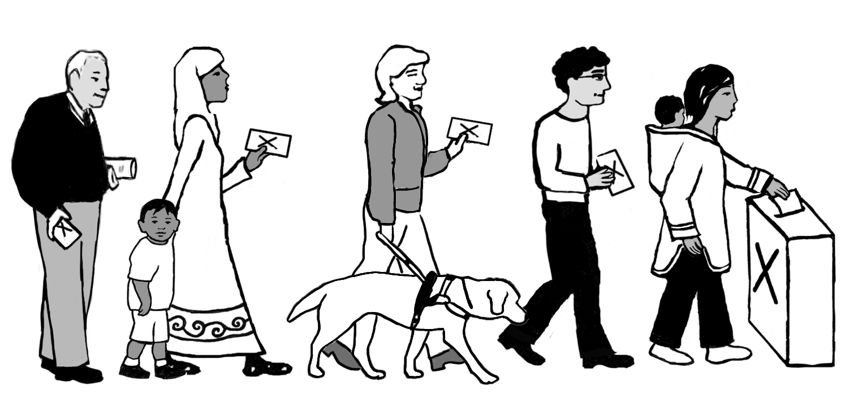

**This document was completed on Sept 14, while Parties continue to share their platforms**. Look for updated version on makingvotescount.ca or visit the Party websites.

**Make your choice, vote and encourage others to vote**.

**Making Votes Count Where We Live Project**

**Coalition of Community Health and Resource Centres**

**City for All Women Initiative (CAWI)**

| **Ottawa Centre** | **Conservative Party**  ~ Stephen Harper  (Candidate Damian Konstantinakos)  **www.conservative.ca** | **Green Party** ~ Elizabeth May  (Candidate Tom Milroy)  **www.greenparty.ca** | **Liberal Party** ~Justin Trudeau  (Candidate Catherine McKenna)  **www.liberal.ca** | **New Democratic Party (NDP)**  ~Tom Mulcair  (Candidate Paul Dewar)  **www.ndp.ca** |
| --- | --- | --- | --- | --- |
| **Affordable Housing**  row-houses2 | - Increase the allowable tax free withdrawals from RRSP accounts by $10,000 (Home Buyers’ Plan)  -Take concrete action in coordination with provinces to curb foreign speculation in Canada’s residential real estate market. | - Implement *a National Housing Strategy* that would move people experiencing homelessness into permanent housing, and provide supports.  - Subsidize private developers to include a percentage of affordable housing in their housing projects. | - Dedicate funding for affordable housing and seniors facilities.    - Renew federal leadership in affordable housing, help build more housing units, refurbish existing ones, renew existing co-operative agreements, and provide operational funding support for municipalities. | - Address priority mandate to tackle affordable housing and homelessness across Canada.  - Commit to federal government being a “long term stable partner in building affordable housing”. |
| **Affordable Quality**  **Child Care**  daycare-centre-web | -Replace the Child Tax Credit with enhanced UCCB  - Add a UCCB of $60/month for 6-17 year olds  - Allow income splitting for couple families  - Increase the taxable Universal Child Care Benefit (UCCB) from $100/month to $160/month for 0-5 year olds  - Increase the Income Tax Child Care Expense Deduction by $1000 | - Restore the 2005 agreements to establish a universal child care program across Canada  - Reform tax and labour policies to allow families to spend more time together – integrating supports, tax cuts, etc  - Provide workplace child care spaces, and speed up the creation of this by providing a direct tax credit to employers of $1500 per child each year;  - Value the decision of parents who choose to stay home with their children. | - Prioritize investment in early learning and child care.  - Fund the creation of thousands of new child care spaces, enhance their quality, and ensure that affordable child care spaces are available to more families who need them.  - This will be part of the increased investment in social infrastructure. | - Build an affordable *universal national child care program;* “affordable” = no more than $15 per day per child.  - Support or maintain the creation of one million new child care spaces within eight years; in first four years, fund 370,000 new affordable child care spaces with an annual investment of $1.9B.  - Ensure and cost-share (60% federal, 40% Provinces/Territories) long-term, predictable transfer funds to provinces/territories to be phased in over an eight-year time period. |
| **Affordable**  **Transit**  **oc-transpo-accessweb** | *- Economic Action Plan 2015* proposes to provide $750 million over two years, in 2017–18, and $1 billion annually ongoing thereafter in a new *Public Transit Fund.*  - Amended Criminal Code to ensure that assaults against transit operators are treated more seriously in the courts ( “aggravated assaults” ) | - Increase existing federal funding to stimulate re-investment in public transportation, pedestrian, cycle and car-sharing infrastructure in all Canadian towns and cities  - Fund ‘*Green Cities’* initiatives, to reduce sprawl and pollution, increase densification, and expand public transit  - Re-invest in our national rail systems, building more train cars in Canada, phasing in high speed rail where feasible, and creating green transportation and energy infrastructure corridors in key regions. | - Triple federal investment in public transit over the next four years to ensure that federal government pays its share of capital, interest, and any additional charges to ensure both new construction and a state of good repair for transit facilities  - Flexible funding to meet requirements of municipalities, in order to maximize the number of public transit projects that are built in Canada | *- Better Transit Plan*: start to close the infrastructure funding gap by transferring an additional cent of the existing gas tax to municipalities  - 20-year plan calls for $1.3 billion to be invested into transit annually  - Create a special funding envelope just for transit with permanent commitment |
| **Good Jobs for All**  we-want-good-jobs-eng | - Expand *Apprenticeship Job Creation Tax Credit* to support skills training.  - Establish *Canada Job Grant,* skills-training that leads to employment.  - Foreign Credential Recognition Loans; add $8 million per year to help internationally-trained professionals.  - Lower taxes for small business from 11% to 9% and lower EI premiums by 20%.  - Reduce ‘red tape’ burden for businesses.  - Provide support to small and medium businesses to take advantage of free trade opportunities. | - Boost access to apprentice programs in key trades.  - Establish a *Green Venture Capital Fund* to support local businesses and start-ups.  - Exempt small businesses from increases in corporate taxes.  - Encourage private sector investment in Green Tech, Green Energy (7x more jobs than traditional energy sector).  - Reduce paperwork burden for small businesses.  - Put thousands of Canadians to work upgrading aging infrastructure. | - Invest $200 million annually to support innovation and clean technologies in forestry, fisheries, mining, energy, and agriculture.  - Ensure education and economic opportunity for First Nations, based on respect for Aboriginal and Treaty rights.  - Support emerging clean tech companies: research, commercialization, and skills training.  - Renew Youth Employment Strategy: $300 million per year. | - Reinstate the *federal minimum wage* and set it at $15 an hour (will apply to federally regulated industries like banking, telecommunications and transportation).  - Support small business, cut the small business tax rate from 11 to 9%.  *- Innovation Tax Credit* to encourage investment in machinery, equipment and property used in innovation-boosting research and development.  - Introduce new tax credits to businesses hiring Canadians aged between 18 and 25 – up to $1,000 per youth and training funds. Double tax credit where youth unemployment is high. |
| **Good Food for All**  **good-food-for-all** | Nothing found to date, take a look to see what you can find  4_20 | - Work towards affordable food and adequate income for farmers  - Support family farmers as environmental stewards and as efficient producers of nutritious food. Agricultural policies must be designed to keep family farms economically viable.  - Think local – encourage local direct sales, trade food for work with local plots, teach food growing and processing  - Encourage agricultural cooperatives  - Better controls on land speculation | - Begin a federal *Healthy Start* program to support existing programs helping low income children access healthy, home-grown food. ($40M over 4 years)  - Ongoing support for *Canada Prenatal Nutrition Program*(CPNP) and *Aboriginal Head Start Program*(AHSP).  - Create a *Buy Local Fund* to support local farmers.  - Create a *Farmers’ Markets Development**Program* to help grow Canada’s farmers’ markets. | - Foster community economic development: to re-localize food production, processing and distribution  - Ensure more profits reach farmers through direct sales or social enterprise  - Support cooperatives.  - Strengthen links between farmers and grocery chains  - Develop a pan-Canadian food policy to include:   * every child and senior have healthy meal * reduced reliance on food banks * incomes and supports for working families, so they can afford healthy food. |
| **Poverty**  **Reduction**  **PAG 61** | In 2007, Conservatives introduced Workers Income Tax Benefit: federal refundable tax credit that boosts the earned incomes of eligible low-income working individuals and families.man-at-microphone | - The most effective way to address poverty nationwide is to make homelessness history – see Affordable Housing section.  - Start with a stronger commitment to guaranteeing that all families have the ability to provide for their children.  - Recommit to a vision of Canada as a just society built around a progressive, fair, and compassionate social safety network.  - Establish a *Guaranteed Livable Income*, to ensure no Canadian falls below an income level needed to live with dignity | - Raise taxes on the wealthiest 1%, so as to cut taxes for the middle class  - Create new *National Child Benefit* that would combine family tax and transfers*,* with significantly higher annual allowances for low-income families  Increase current federal infrastructure investment by $10 billion per year, with priority given to affordable housing and seniors facilities, early learning and child care, and cultural or recreational infrastructure. | - Introduce *National Poverty Elimination Act* – federal plan to reduce then eliminate poverty through coordinated policies: affordable housing, universal, affordable and available childcare, and reforming *Employment Insurance*  - Boost *Guaranteed Income Supplement* by $400 million  - Reverse the plan to raise the age eligibility for *Old Age Security* from 65 to 67  - Enhance *Working Income Tax Benefit and National Child Benefit Supplement* |