Bannock Bus Route  Centre Town Community Health Centre (4:00)  Minto Park (Elgin St.) (4:30)  Sandy Hill (Chapel and Mann) (5:00)  Metro (Rideau St.) (5:30)  Scotia Bank (Montreal Rd) (6:00)  Ottawa Freedom Centre (Montreal Rd) (6:30)  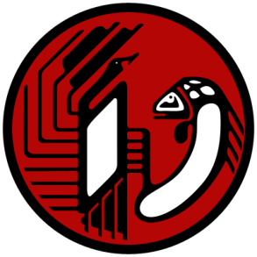 | Bannock Bus Route  Centre Town Community Health Centre (4:00)  Minto Park (Elgin St.) (4:30)  Sandy Hill (Chapel and Mann) (5:00)  Metro (Rideau St.) (5:30)  Scotia Bank (Montreal Rd) (6:00)  Ottawa Freedom Centre (Montreal Rd) (6:30)
Bannock Bus Route  Centre Town Community Health Centre (4:00)  Minto Park (Elgin St.) (4:30)  Sandy Hill (Chapel and Mann) (5:00)  Metro (Rideau St.) (5:30)  Scotia Bank (Montreal Rd) (6:00)  Ottawa Freedom Centre (Montreal Rd) (6:30) | Bannock Bus Route  Centre Town Community Health Centre (4:00)  Minto Park (Elgin St.) (4:30)  Sandy Hill (Chapel and Mann) (5:00)  Metro (Rideau St.) (5:30)  Scotia Bank (Montreal Rd) (6:00)  Ottawa Freedom Centre (Montreal Rd) (6:30)

