Intentional Peer Support Training
  SESSION ONE:  Day 1: Monday, March 14 - Boardroom D  Day 2: Tuesday, March 15 - Boardroom D  Day 3: Thursday, March 17 – Activity Room (401)  Day 4: Monday, March 21 - Boardroom D  Day 5: Tuesday, March 22 - Boardroom D  Day 6: Thursday, March 24 - Boardroom D |   SESSION TWO:  Day 1: Tuesday, March 29 – Boardroom D  Day 2: Thursday, March 31 – Boardroom D  Day 3: Tuesday, April 5 - Boardroom D  Day 4: Thursday, April 7 - Boardroom D  Day 5: Tuesday, April 12 - Boardroom D  Day 6: Thursday, April 14 - Boardroom D
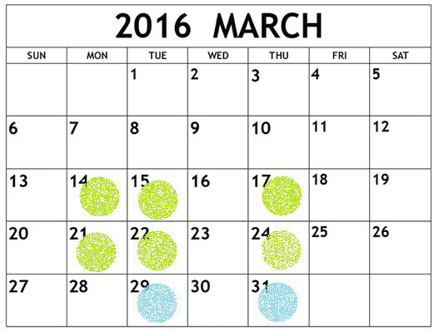 | 