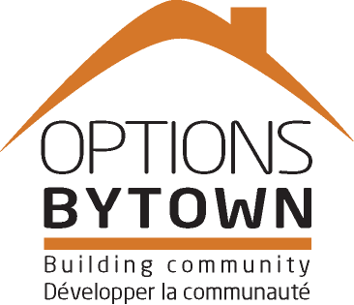A**Options Bytown Non-profit Housing Corporation**

***You are invited to attend the Annual General Meeting***

***Of Options Bytown Non-profit Housing Corporation***

**THURSDAY, JUNE 16TH, 2016**

**4:00 pm – 6:00 pm**

**Heartwood House**

**205A-404, McArthur Ave.**

**On-site parking or bus # 14 St. Laurent**

**R.S.V.P. No later than June 10 (613) 241-6363 #223 or info@optionsbytown.com**

* **Winner of the 10th Annual “Make Homelessness History Award”**
* **Winner of the 8th Annual “Media Award for Excellence”**
* **Tenants’ stories about the journey from homelessness to housing**
* **Volunteer Recognition**
* **Business Meeting**
* **Refreshments**

**Our Vision**

Provide leadership and support to end homelessness

**Our Mission**

Offer permanent housing and supports to assist people at risk of homelessness live independently and enrich their lives.