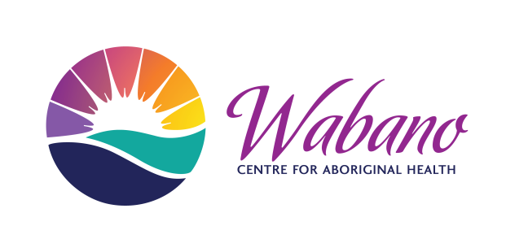 **Wabano Centre for Aboriginal Health &**

**Vancouver Native Health Society Presents**

** **

**Inviting you to a FREE community event**

**September 21st, 2016 10:30 am - 3:30 pm**

**Wabano Centre for Aboriginal Health (299 Montreal Rd)**

*An opportunity to talk about Indigenous men’s health issues, urban health issues and community as experienced in Ottawa and Vancouver.*

**There will be cultural performances and lunch will be provided**

**Please RSVP to:** [**lyana.patrick@alumni.ubc.ca**](mailto:lyana.patrick@alumni.ubc.ca)

