December 22nd, 2016

Dear community partners,

It is with great regret that I must inform you that Étienne Grandmaître Saint-Pierre, will be leaving his position as Executive Director of Action-Logement / Action Housing on February 20th, 2017, to pursue other opportunities.

On behalf of the Board of Directors and of the staff, I would like to recognise Étienne’s devotion to our cause and thank him for his service. Action-Logement / Action Housing serves over 2 400 clients every year, each one a low-income family or individual living with housing insecurity.

Our organisation has been working since 1989 to combat housing insecurity. Access to to healthy, safe and affordable home leads to better health outcomes, better education outcomes and increased employability. Étienne’s work has helped us create better conditions for our clients and our community.

Sincerely,

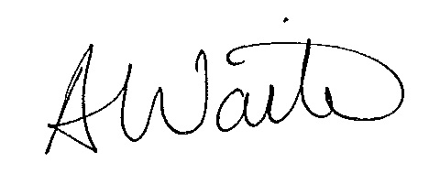
Alexandra Waite
Chair of the Board of Directors
Action-Logement / Action Housing

