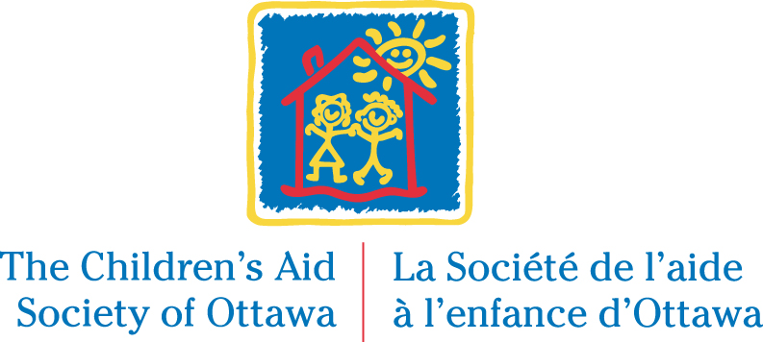

SUPERVISOR – FAMILY VISITATION PROGRAM
Permanent Full-Time Position, Non Union

The Children’s Aid Society of Ottawa (CAS) is non-profit community organization funded by the Government of Ontario, legally mandated to protect children and youth from abuse and neglect. The CAS is one of over 46 agencies across the province regulated by the Ministry of Children and Youth Services and governed by the Ontario Child and Family Services Act (CFSA).

We are currently searching for a dynamic person to join the third largest Children’s Aid Society in Ontario, to fulfill the role of a Supervisor in our Family Visitation Program.

Responsibilities:
The Supervisor of the Family Visitation Program reports to the assigned Director, Services or his/her delegate. Under the direction of the assigned Director, the supervisor will oversee the delivery of service in the Society’s Family Visitation Program in a manner that is consistent with best practice in the field of child welfare and child development. The scope of this position requires flexibility for coverage of various programs.

The Supervisor is responsible for managing the work of an assigned group of staff and works flexible hours to support the program and assigned staff. This involves scheduled and unscheduled evening/weekend program activities as well as general after hours availability including weekend emergency support and consultation.

Requirements:
- BSW, or MSW, or Bachelor Degree with an additional graduate degree in a related field is required;
- Minimum of five years of demonstrated highly satisfactory performance within child welfare setting including direct service experience and progressively increasing leadership experience;
- Supervisory experience is an asset;
- Strong knowledge of the CFSA;
- Demonstrated knowledge and experience working with issues of violence against women
- Demonstrated knowledge and application of the Differential Response Systems;
- Sound clinical knowledge of the principles and practice of child welfare;
- Demonstrated competencies in working with the cultural and aboriginal communities;
- Strong problem solving and conflict resolution skills;
- Strong administrative, planning and organizational skills;
- Strong communication skills;
- Represent the Society on committees and boards as required;
- Bilingual in English and French is considered an asset.

Position available: ASAP

We offer a salary range of $79,244 - $103,747, commensurate with skills and experience, including a comprehensive benefits package (pension plan and health & insurance benefits) and generous leave provisions (such as 4 weeks of vacation after 1 year of service). Our modern workplace has excellent physical amenities including a fully equipped gym, free parking and a cafeteria

If you are interested in the above opportunity, please apply online on our website at www.casott.on.ca, by 11:59 p.m., Sunday, April 29 2018.

We thank all applicants for their interests in the Children’s Aid Society of Ottawa, however we will only contact those selected for an interview.

CASO is committed to a candidate selection process and work environment that is inclusive and barrier free. In order to ensure candidates are assessed in a fair and equitable manner, accommodations will be provided to prospective employees in accordance with the Accessibility for Ontarians with Disabilities Act (AODA) and the Ontario Human Rights Code.

The Children’s Aid Society of Ottawa is dedicated to building a workforce that reflects the diversity of the community in which we live in and serve. The Society encourages applications from all qualified individuals.

