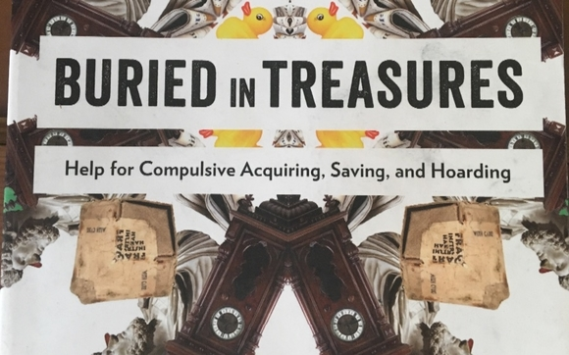

**Distressed or Overwhelmed about the amount of stuff in your living space?**

**Do your accumulated treasures interfere with your life, relationships or happiness?**

**You are not alone!**

We invite you to sign up for our FREE 15 week Support Group based on the book: “Buried in Treasures. Help for Compulsive Acquiring, Saving and Hoarding”

Our group is set begin in mid January. If you are seeking a solution and the support to follow it through, please contact Joyce at Options Bytown:

613-241-6363 ext 245

or

jlundrigan@optionsbytown.com