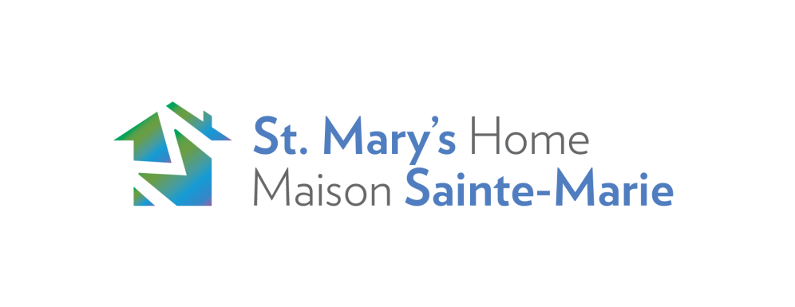

## Casual Relief

**Job Description**

Searching for **Casual Relief or Part Time Primary Key Counsellors in our shelter**

These positions require a **CYC or SSW** diploma or equivalent and experience working with youth at risk will be an asset - **bilingual also an asset**.**

**PRIMARY CARE COUNSELORS in our RESIDENCE THREE PRIMARY FUNCTIONS:**

**Shift Coordinator: Demonstrates a comprehensive understanding of the role of Shift Coordinator and competently carries out Shift Coordinator oversight for safety and medication management.**

Support Counselor: Has a solid understanding of the Support Counselor functions. Is skillful in positively engaging clients; Capable of providing clients with emotional support; conflict management support, crisis intervention support and hands on support; Adept in day-to-to operation including admissions & discharge procedures, reporting and recording practices.**

Parenting Counselor: Proficient in the Parenting Counselor Responsibilities to provide clients with Direction-Observation-Teaching-Support in regards to parents providing direct baby care; to actively promote and support clients with infant play & development; and in fostering parent positive interactions with their infants that promote infants secure attachment to their parent**

PLEASE INCLUDE COVER LETTER

Job Type: Casual

Please apply Via Indeed or you can email your resume and cover letter to [cindirye@stmaryshome.com](mailto:cindirye@stmaryshome.com)