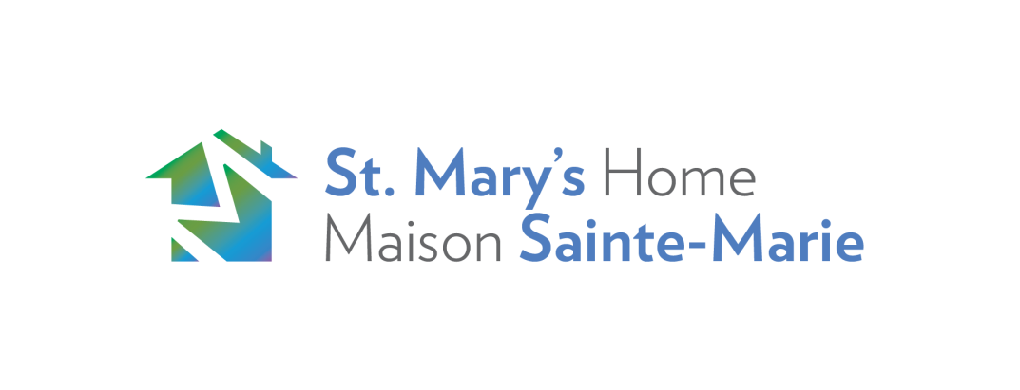

## Support/Intake Attachment Counsellor

**Job Description**

Individual functions independently and within a multidisciplinary team to provide professional services to the participants of St Mary’s Home during Parent / Child drop in programs and in child care programs. Some program facilitation may be required. The position is full time 35 hours per week. This position includes days, some evening work and may require occasional week end hours. The candidate for this position will maintain a high level of integrity and exercise sound judgment while maintaining confidentiality in adhering to professional practices in the field.

**Qualifications**:

* Child and Youth Worker/Social Service Worker / Social Worker/ BA Social Science or equivalent
* 2 years experience working with Parent / child interactions

Knowledge and Skills:

* Knowledge and understanding of infant mental health and specific training in working with the Attachment Dyad.
* Experience with intakes and assessment tools
* Experience with strength based, client centered, trauma and attachment informed approaches with a practical understanding in best practices using these approaches in conjunction with one another
* Excellent communication and interpersonal skills
* Compassionate, enthusiastic and ability to take initiative
* Ability to work independently and also as a cooperative member of a Multi-Disciplinary team in a client centered, strength based, trauma informed environment
* Ability to work flexible hours
* Experience with program facilitation and evaluation
* Excellent organizational and problem solving skills
* **An understanding of the barriers and challenges faced by pregnant and parenting youth**
* Knowledge of community and social service resources, in particular services for pregnant and parenting youth
* An understanding of and commitment to anti-discriminatory practices
* Experience with electronic files and data base
* Bilingual preferred (English and French)
* PLEASE INCLUDE A COVER LETTER
* PLEASE ONLY APPLY IF YOU MEET THE REQUIRED LANGUAGE/EDUCATION/FLEXIBLE AVAILABILITY

Job Types: Full Time, Permanent

Job Type: Full-time

Please apply Via Indeed or you can email your resume and cover letter to [cindirye@stmaryshome.com](mailto:cindirye@stmaryshome.com)