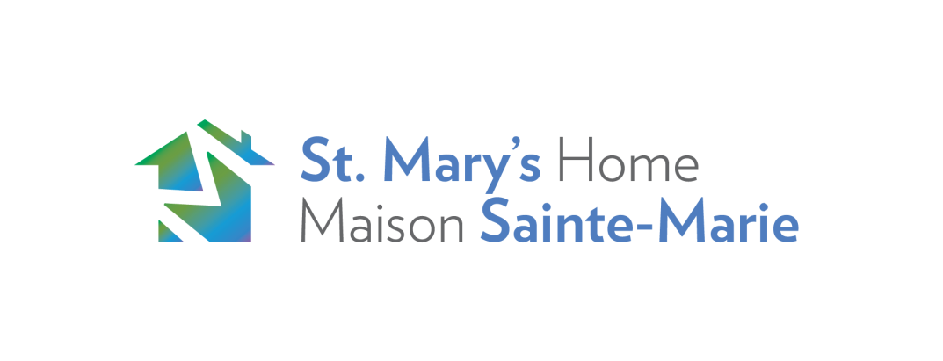

**EMPLOYMENT OPPORTUNITY**

SMH has an immediate opening for a full time, 35 hours a week,

**Intake/Support Counsellor**

**Please send a cover letter along with your resume and state the reasons for your interest and identify your suitability for this position.**

**The Deadline for applying is: *February 21, 2019 at Noon.***

**Please note, applications will be processed as received and the position may be filled prior to the closing date.**

**Apply in confidence by email to:**

debbiebarriault@stmaryshome.com

Debbie Barriault, Director of Client Services

## *We thank all applicants but only those selected for an interview will be contacted. No phone calls please.*

**Position Summary:** The Intake/Support Counsellorfunctions independently and within a multidisciplinary team to provide, and ensure, appropriate services and supports are available for pregnant and parenting youth and their children and infants. The position is 35 hours per week and includes weekdays, some evening work and may require occasional week end hours. The candidate for this position will maintain a high level of integrity and exercise sound judgment while maintaining confidentiality in adhering to professional practices in the field.

**Responsibilities:**

**Support Services:**

* Conduct intakes and assessments and make referrals to appropriate network services and community resources;
* Establish and maintain positive, trusting and supportive relationships with St. Mary’s Home participants;
* Provide one-to-one, short term support counseling to vulnerable pregnant and parenting youth;
* Provide crisis support with follow-up referral and intervention;
* Support clients during times of high stress and transition;
* Facilitate regular programs, groups and workshops; and
* Work within an infant mental health and attachment-informed framework.
* Familiar with strength based and trauma informed approaches

**Program Development, Delivery and Coordination:**

* Develop, plan, implement, facilitate and support activities and programs;
* Maintain appropriate documentation and records;
* Participate in ongoing evaluation of programs and services;
* Participate in relevant continuing education; and
* Additional duties as required by the needs of the Agency.

**Community Interface:**

* Advocate for pregnant youth and young parents in the community;
* Develop and implement outreach strategies;
* Project a positive image of St. Mary’s Home;
* Participate in promotion St. Mary’s Home;
* Maintain knowledge of and liaise with pertinent community resources;
* Participate on committees/teams at St. Mary’s Home, and within the community where necessary;
* Demonstrate a clear understanding of appropriate role-modeling and maintain professional standards as designated in St. Mary’s Home Policies and Procedures Manual;
* Complete all HR Training Courses as explained in the St. Mary’s Home Policies and Procedures Manual; and
* Work in compliance with the Health and Safety Act and Regulations and report any violations of the Act to one’s immediate supervisor.

**Qualifications:**

* Bachelor’s degree in Social Work, Child and Youth Worker Diploma, Social Service Worker Diploma; or the equivalent; and
* Minimum 3 years experience working with pregnant and parenting youth.

**Knowledge and Skills:**

* Experience using intake and assessment tools;
* Experience in support counselling, program development, facilitation and evaluation;
* An understanding of the barriers and challenges faced by pregnant and parenting youth;
* Knowledge of community and social service resources, in particular services for pregnant and parenting youth;
* Ability to work independently and also as a cooperative member of a Multi-Disciplinary team;
* Experience working from a strength based, client centered, trauma and attachment informed approach with a practical understanding in best practices using these approaches in conjunction with one another;
* Knowledge and understanding of infant mental health and child development;
* Knowledge and understanding of Attachment is considered an asset;
* An understanding of and commitment to anti-discriminatory practices;
* Excellent communication and interpersonal skills;
* Excellent organizational and problem solving skills;
* Experience keeping electronic files and working with a data base;
* Compassionate, enthusiastic and ability to take initiative; and
* Ability to work flexible hours;
* **Bilingual in English and French required**

PLEASE ONLY APPLY IF YOU MEET THE LANGUAGE REQUIREMENT