 | SHELTER (ALTERNATIVES)  CORPORATION
AN AFFORDABLE HOUSING CORPORATION
Website: https://omraottawa.org
OMRA Holiday Hamper Fundraiser – Sale of Grocery Cards
OMRA Shelter Corporation, a not-for-profit organization, provides portable, monthly rent subsidies to 24- 30 refugee families each year. Since 2002, OMRA has run a monthly grocery card fund raiser, supported by local churches and synagogues as well as individuals and neighbourhood groups who order and receive cards. The grocery stores give OMRA 4-5% of the total amount of the OMRA bulk order and the buyer gets the full value of the grocery card. This fund raiser provides about $40,000 per year for the rent subsidies.
New for 2021 - Christmas/Holiday Hamper Fundraiser – The Gift That Gives Twice!
In order to raise money to increase our rent subsidies, OMRA is offering the cards to community centres, churches, individuals and workplace groups who want to include grocery cards in their Christmas (Holiday) Hampers. The cards need to be ordered as soon as possible and will be available for pick up after Dec 12, 2021.
To place an order and for further information: Contact Maria Rigby at rigby.omra@gmail.com

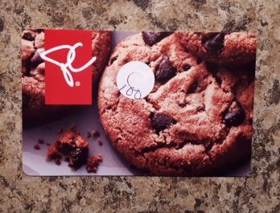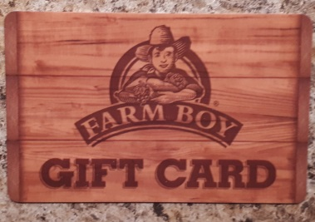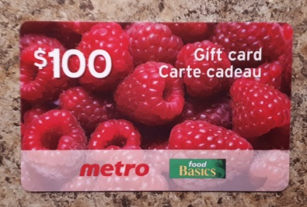

Denominations available:
Loblaws/Superstore/No Frills/Independent - $25.00, $50.00 and $100.00 denominations
Shoppers Drug Mart - $50.00 denominations
Farm Boy - $25.00, $50.00 denominations
Metro/Food Basics – $25.00, $50.00 and $100.00 denominations
______________________________________________________________________________
Thank you for supporting OMRA Shelter Corporation’s newcomer rent subsidy program.

