# Slide 1: iAccess Tech:

**Empowering Inclusive Futures**

**Master Your Mobile Devices: Organize, Simplify and Thrive**

**Swipe, Tap, Done!**

**Tuesday June 24, 2025**

**12pm**

# Slide 2: Who am I?

* My name is Lynda Muckleston
* I’m an instructional designer with iSisters with a focus on accessibility
* I’m passionate about using technology to help me successfully manage my day
* I have a brain injury so rely on some of the features we are going to discuss today.
* My two adult children are out on their own, but they use some of the strategies I will share with you today.
* My other passions are gardening, yoga and swimming

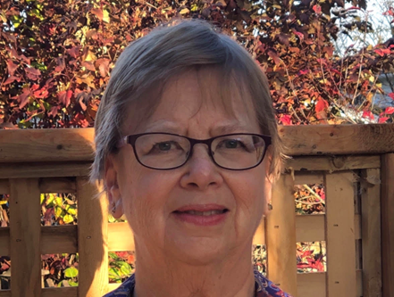

# Slide 3: Navigating Zoom

ID: Zoom tool bar – where you find Live Captions and language



ID: Where to find languages

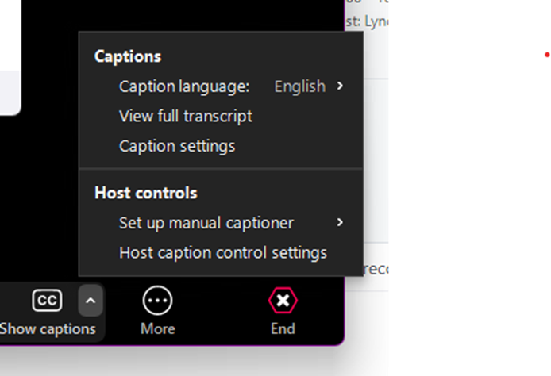

ID: Where to find reactions



# Slide 4: Land Acknowledgment

Here at iSisters, we respectfully acknowledge that we work and live on the unceded and unsurrendered territory of the Anishinabe Nation. We commit ourselves to learn the truth and be active in the process of reconciliation*.*

Ondaje iSisters, nidapiitenindaamin kikenindamang eji ondaamitaayaang ashidj abiyaang ondaje ega wiikaad kamiigiwaaniwang iyo kichi Anishinaabewakii. Niwaawiindamaagemin niinawind kidji-kikenindamang tebwewin ashidj kidji-kwayakijichigeyaang kabii-ijiwebag.

Turtle Island By Patrick Hunter-Indigenous artist

Turtle Island, a painting by Patrick Hunter and Indigenous artist.


# Slide 5: Introduction

## **What are we talking about today?**

We are so used to using our mobile devices to check our email, texts and of course talk to our friends and family, we forget to check out some of the more useful apps that can help us move through the day with less stress.

So, lets learn how we can “Swipe, Tap and Done”, our way through the day**.**

# Slide 6: Transportation

**Transit**- Provides real-time data for public transportation (OC Transpo)

**Live Traffic (Ottawa)-**real-time road conditions, traffic updates, and map information

**Cabs/Uber**-Uber, Ottawa Taxi App, Blue Line Taxi, Capital Taxi or Taxitab

# Slide 7: Weather

# Weather Pro

# Environment Canada

# The Weather Network

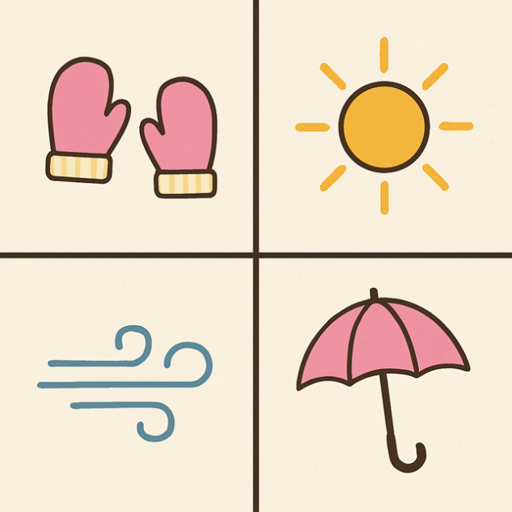

# I.D. 4 images representing the 4 seasons

# Slide 8: Shopping

**Groceries/Coupons**-Checkout 51, all major grocery store apps

**General-** major stores, Amazon, Wayfair

Slide 9: **Menu Planning/Recipe Organizing**  
Meal Planning-Don’t forget to use AI for helpful menu planning

Organizing- All recipes or COOKmate

# Slide 10: Financial

**Banking**-major banks

**Digital Wallet**-having cards handy on your device

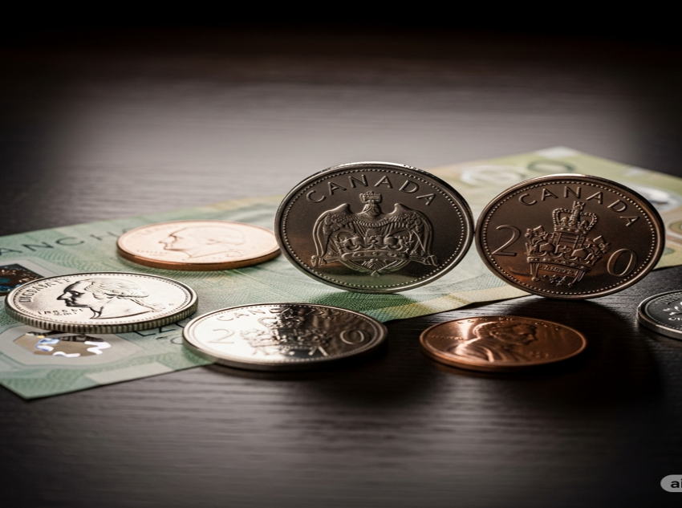

I.D. Canadian money

# Slide 11: Language/Translation

**DEEPL-**real-time voice, text, and camera translate as well as pronounce guides.

**Google, Microsoft, Apple-**all have translation apps, depending on your device

# Slide 12: Communication

These are the apps we are most familiar with:

* Email
* Texting
* Talking
* Video meetings

# Slide 13: Notes on the Go!

**Voice Memo**

**Siri/Alexa/Google**

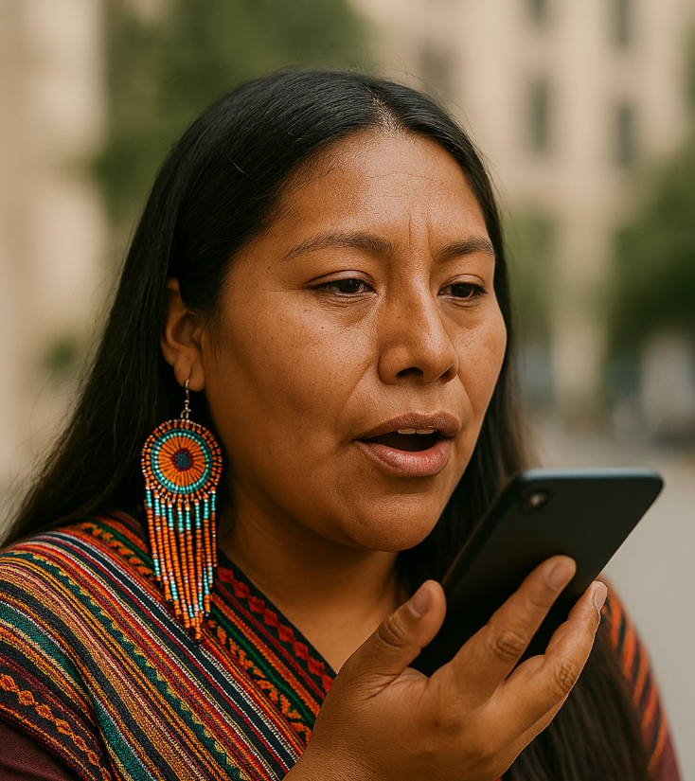

I.D. A woman voice activating her cellphone.

# Slide 14: Entertainment

* Reading
* TV/Movies

# Slide 15: What We Learned About Today

Transportation Financial

Weather Language/Translation

Shopping Communications

Menu planning Entertainment

# Slide 16: Looking to the Future!

Our next iAccess Tech topic is “**Organization and Time Management with Google Tools”.**

**We would love to hear any suggestions you might have for future workshops, so please before you leave fill in the poll.**

# Slide 17: Questions and Contact

**Lynda Muckleston**

**instrdes2@isisters.org**

# Slide18: Thank You!

Thank you all for your interest in our workshops and for attending.



We extend our special thanks to Ciena for their generous funding and support of this program.

# Slide 19: Additional Resources

[The Creation Story-Turtle Island](https://ltbbodawa-nsn.gov/wp-content/uploads/2020/12/The-Creation-Story-Turtle-Island.pdf)