News Release

6911 No. 3 Road, Richmond, BC V6Y 2C1
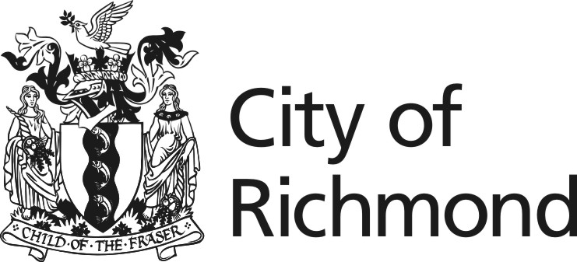
June 25, 2026

For Immediate Release

City’s Heritage Boat Restoration Program
earns provincial and regional recognition

Richmond, BC – The City of Richmond’s Heritage Boat Restoration Program at Britannia Shipyards National Historic Site has received two prestigious awards recognizing its innovation, educational value and contribution to preserving local maritime heritage.

The program was honoured with the Tourism Richmond EPIC Award for Innovation in November 2025 and the Heritage BC Award for Education, Communications and Awareness in May 2026. Richmond City Council formally recognized the Heritage BC Award at its May 25 meeting.

The Program offers visitors a rare opportunity to observe live wooden boat restoration work while learning about the rich history of Japanese Canadian boatbuilding in Steveston. Through hands-on conservation activities, educational programming and exhibits, the initiative connects residents, students and visitors with an important chapter of Richmond’s maritime heritage.

A central feature of the program has been the restoration of the Crystal S, a wooden fishing vessel built by Steveston Japanese Canadian boatbuilder Mamoru Sakamoto in the 1960s. The restoration has served as a living classroom and public demonstration project, allowing audiences to follow the vessel’s transformation while gaining insight into traditional boatbuilding techniques.

The Tourism Richmond EPIC Award for Innovation recognized the program’s success in enhancing the visitor experience at Britannia Shipyards by providing an engaging behind-the-scenes look at heritage restoration while sharing the stories and traditions of Japanese Canadian boatbuilders. The program has attracted significant public interest through media coverage and was featured during the Travel Media Association of Canada Conference hosted in Richmond in April 2026.

The Heritage BC Award recognized the program as an outstanding example of heritage education, communication and public awareness. The Program was selected for being an outstanding model for connecting heritage preservation with public learning that is hands-on and deeply rooted in the community, increasing understanding and appreciation of the history, craftsmanship and traditions associated with Japanese Canadian boatbuilding in Steveston.

The Heritage Boat Restoration Program continues to welcome visitors to Britannia Shipyards, where they can experience heritage conservation in action and discover the stories that shaped Richmond’s fishing community.

For more information about the Heritage Boat Restoration Program and upcoming opportunities to visit Britannia Shipyards National Historic Site, visit britanniashipyards.ca.

- 30 -

Media Contact:
Dammy Ogunseitan
Director, Corporate Communications and Marketing
Tel: 604-276-4399 Cell: 778-227-4415
Email: DOgunseitan@richmond.ca

Your email address has been recorded in our media contact database. In the future, you will receive news releases and media advisories. To unsubscribe at any point, please email us at communications@richmond.ca with “Unsubscribe to media list” in the subject line.

