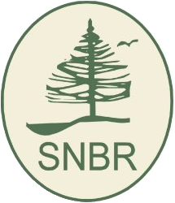 Southwest Nova Biosphere Reserve Association__

Cliff Drysdale, Chair
Southwest Nova Biosphere Reserve Assoc.
RR#1 Middleton, NS B0S 1P0

E-Email: cliff.drysdale10509@ns.sympatico.ca

Website: www.swnovabiosphere.ca

Phone: (902) 825-4884
August 6/15

News Release:

The UNESCO Southwest Nova Biosphere Reserve Association with the support of municipal units in the region has collaborated with the Applied Geomatics Research Group (AGRG) of the Nova Scotia Community College (NSCC) Annapolis Valley Campus to launch a unique social enterprise project.

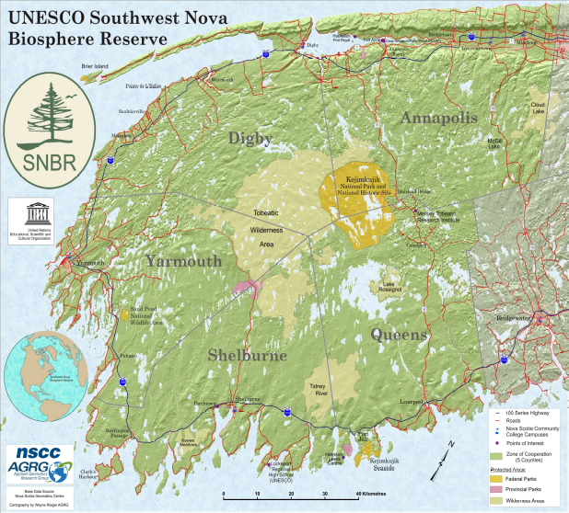
The innovative “Touring Through Time/Une Tournée Dans L'Passé” smart phone/tablet ‘Map App’ provides information and website access to towns, attractions, transportation, accommodation, weather, tide times, and user location within 5 Counties under “Culture, Outdoor, Seacoast, and Lighthouses” headings. The ‘App’ facilitates booking arrangements and encourages visitors to stay and enjoy the southwestern region as a destination area.

The ‘Map App’ will be a useful educational tool for students and residents. It supports access to First Nation websites, the Birchtown Black Loyalist Heritage Centre, the la Baie Saint Marie Acadian Cultural Centre, community museums and many other significant cultural features. Similarly it links with Kejimkujik National Park and National Historic site, the Tobeatic Wilderness Area and other natural features.

The “Touring Through Time/Une Tournée Dans L'Passé” ‘Map App’ can be opened by cell phone or desk top computer via http://swnovabiosphere.ca/our-projects/web-app/. It is also accessible on the website http://www.swnovabiosphere.ca and on the Nova Scotia Tourism Agency website http://www.novascotia.com/see-do/attractions/unesco-heritage-sites in the ‘Top 25 Attractions’ section. It can also be obtained via scanned ‘QR’ code icons on Biosphere Reserve publications

The Southwest Nova Biosphere Reserve, one of the largest in Canada, was designated in 2001 by the United Nations Educational, Scientific and Cultural Organization (UNESCO) as a “site of excellence where new and optimal practices to manage nature and human activities are demonstrated”. The Biosphere Reserve ‘Zone of Cooperation’ includes Annapolis, Digby, Yarmouth, Shelburne and Queens Counties and ‘Core Protected Areas’ Kejimkujik National Park and Historic Site, and the Tobeatic Wilderness Area.

