Unlimited Volunteer Opportunity -- Manager of the North End Community Garden

The North End Community Garden was built in 2014 and offers 22 plots for yearly rentals. Over the years we’ve made several improvements and added a few pollinator gardens to attract more bees & butterflies. The garden is full of flowers and is peacefully situated on both sides of the Parking Lot of Ft. Needham Park, on Union Street. Irene Obermann, the Manager, is transitioning into retirement so
we’re looking for a replacement a.s.a.p.
Here’s what the Manager’s job entails:
- Secures an annual Sponsorship from Mulgrave Park Caring & Learning Center (which submits
grants for us and covers liability insurance (since we are not a Non-profit organization and
the HRM requires it).
- Prepares Registration for new members the last weekend in April.
- Arranges for Water procurement from Needham Rec Center, next door to us.
- Manages the Upper & Lower Gardens (acclimating new gardeners to our routine, arranging for
meetings, workshops & purchase of supplies, etc. and organizing work projects.
- Accounting - of all income & expenses & occasional grants.
- Share gardening tips and tricks with new members and create a welcoming environment for new gardeners and community members.

If you love gardening, live near us and have good people skills, we’d love to hear from you!
Please contact Irene at: ireneobermann50@gmail.com, or call at (902) 817-0460
Here are a few pictures of the garden:

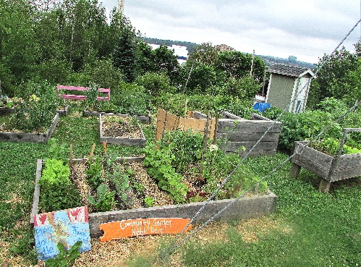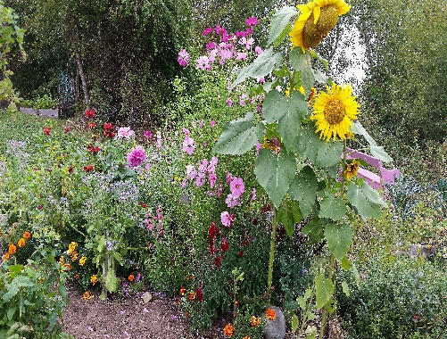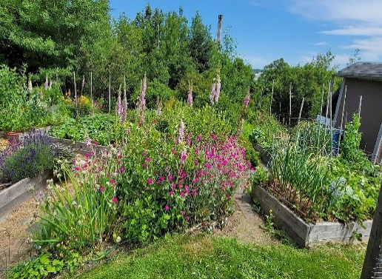
NECG – Upper Garden 2017 Butterfly Garden – 2018 Upper Garden 2021

